**Day_01 (Build/Compile)**

**Source Code =>** The code written by the developers is called Source Code.

**Compilation:**

* Compilation is the process of converting source code written in a high-level programming language (like Java) into machine readable code (bytecode in the case of Java) using a compiler.
* The process of converting high level language into low level language is called Build/Compile.

**Can’t we build the source code without build tools?**

No, we can build the source code without build tools.

* Javac is a compiler to build/compile Java code.
  + There are many build tools (Ant, Maven, Gradle) for Java in the market.

**Why we are using other build tools (Maven or Gradle), even if there is a Javac to compile build/compile Java code?**

* Javac cannot support major features.
* With Javac, you must manually download, manage, and include all dependencies (external libraries) in the class path.
* Javac compiles only Java files. It does not provide a standardized build life cycle (E.g., compile, test, package, deploy)
* Tasks like running tests, creating JAR/WAR files. And deploying to servers are not automated and must be handled separately.
* Javac lacks built-in integration with CI/CD tools, making automation of these processes more difficult.

**C language:**

* Make is the build tool for C language
* When we compile the C language, the Artifacts (output) will be .o or .obj

**Java language:**

* Ant, Maven, Gradle are the build tools for Java
* Artifacts are Jar, War, Ear
* Jar – Java archive (Group of classes)
* War – Web archive (Group of Jars and CSS, Images, Html)
* Ear – Enterprise archive (Group of Wars)

**.NET language:**

* Nant, MsBuild are the build tools for .NET
* Artifacts are .dll (Dynamic Link Library)

**Day_02 (Maven)**

**What is Maven?**

Maven is a powerful build automation tool used primarily for Java projects.

**Is Maven free?**

* Maven is an open-source project and does not belong to any single company.
* It is part of the Apache Software Foundation (ASF), which is a non-profit organization that supports a variety of open-source software projects.

**Latest Version:**

* Version: Maven 3.9.4
* Release Date: 28 June 2023

**Key features of Maven**

Build Automation:

* Maven automates the compilation, testing, packaging, and deployment processes.
* It supports various build life cycles, such as clean, validate, compile, test, package, verify, install and deploy, making the build process more efficient and consistent.

Standard Directory Layout:

* Maven encourages a standard project directory structure, which helps in maintaining consistency across projects.
* This standardization simplifies the build process and makes it easier for developers to understand and navigate the project

Project Object Model (POM):

* Maven uses an XML file called pom.xml to describe the project and manage its configuration.
* The POM file includes information about the project, its dependencies, build instructions, and other details.

Dependency Management:

* Maven handles project dependencies by downloading required libraries and plugins from a central repository, ensuring that all necessary components are available for the build process.

Plugins:

* Maven is extensible through plugins, which add functionality to the build process.
* There are plugins for compiling code, running tests, generating documentation, creating project reports, and more.

Repositories:

* Maven uses repositories to manage project dependencies and plugins.
* The central repository is the default location from which Maven downloads dependencies, but users can also configure additional remote or local repositories.

**Dependency for Maven**

JAVA/JDK should be installed on the server. Then only Maven will work.

**Check the Maven Version**

mvn -version

**Basic Maven Commands/Maven Phases/Maven life cycle:**

* mvn clean => Cleans the project by removing the files generated during the build process.
* mvn compile => Complies the source code of the project.
* mvn test => Runs the tests for the Project.
* mvn package => Packages the compiled code into a distributable format, such as JAR or WAR file.
* mvn verify => Verify the integration checks.
* mvn install => Installs the packaged project into the local repository.
* mvn deploy => Deploys the project to a remote repository.

**Day_03 (Maven installation)**

**Maven installation on RHEL family (Amazon Linux, RHL, CentOS):**

**Step 1: Install Java**

java -version (To check, if java is installed)

mvn --version (To check, if Maven is installed)

sudo yum install java-11-amazon-corretto-headless -y (To install Open JDK 11 version)

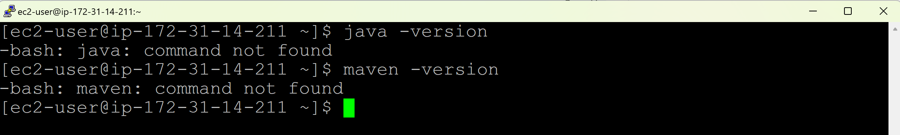

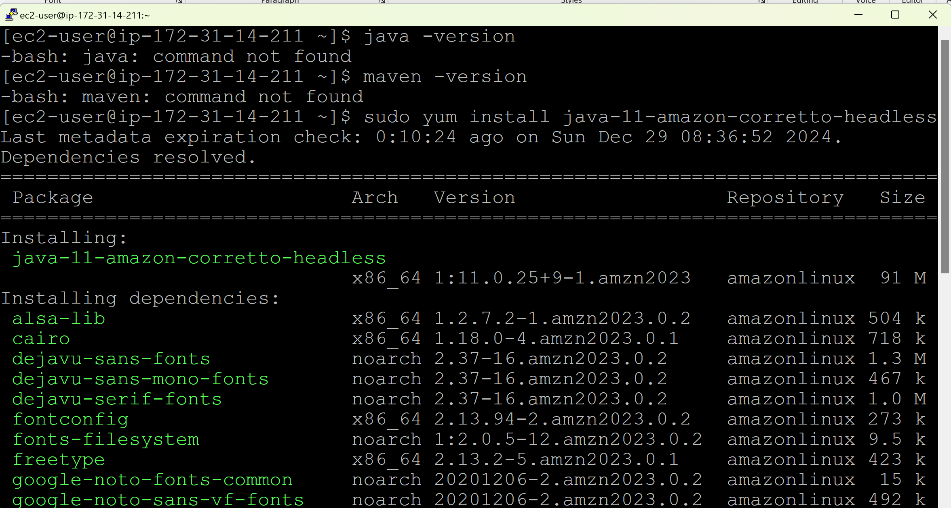

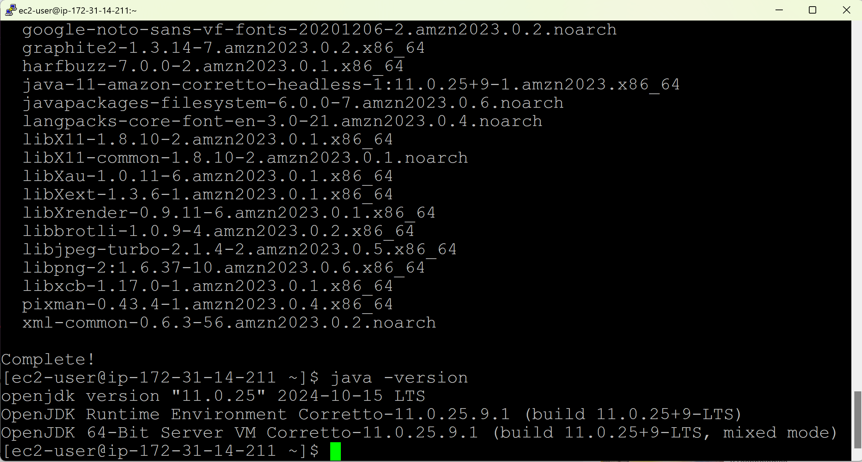

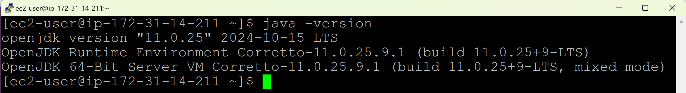

**Step 2: Download Maven**

Go to Browser > Type Apache Maven download > Go to the first link > Copy the first link address

sudo wget <https://dlcdn.apache.org/maven/maven-3/3.9.9/binaries/apache-maven-3.9.9-bin.tar.gz>

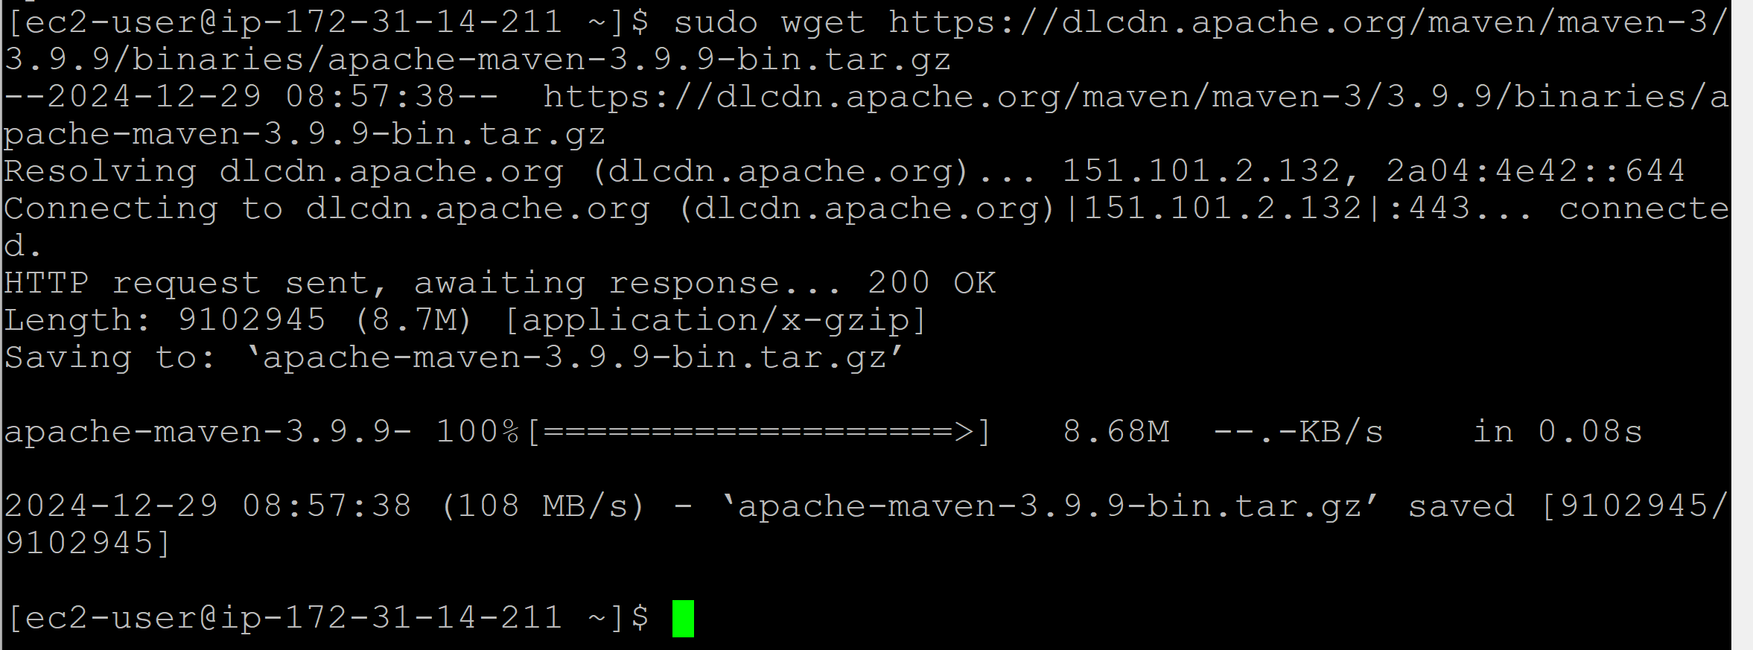



**Step 3: Extract tar file**

tar xvf apache-maven-3.9.9-bin.tar.gz (To extract the tar file)

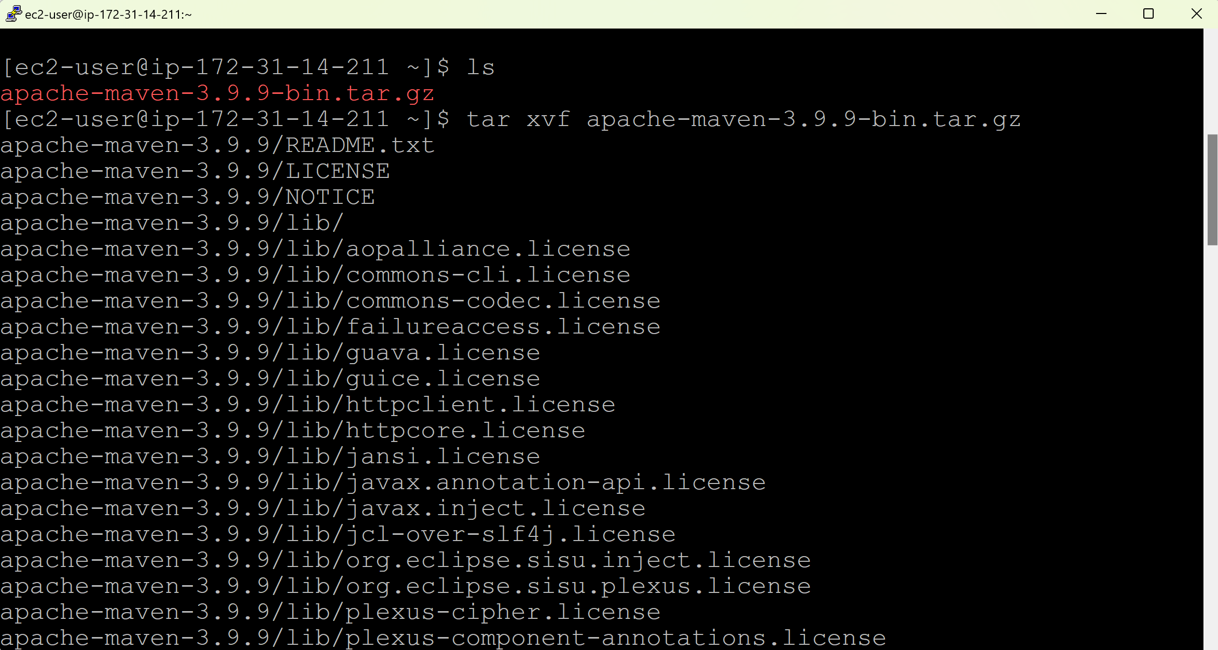

ls (To check, if tar file is extracted)

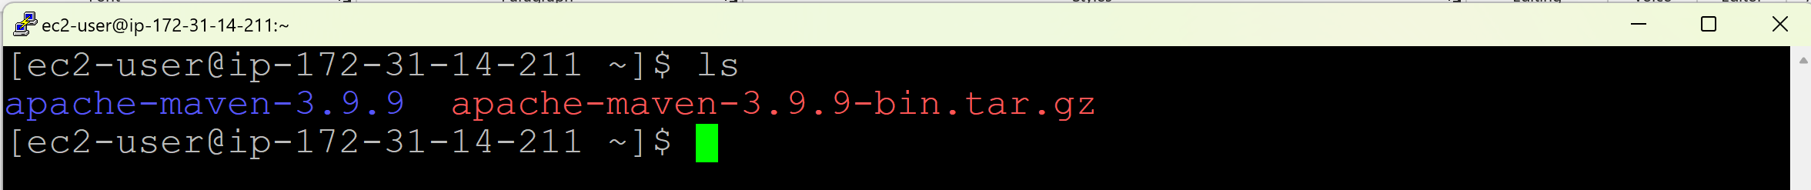

Move to the apache folder

cd apache-maven-3.9.9/

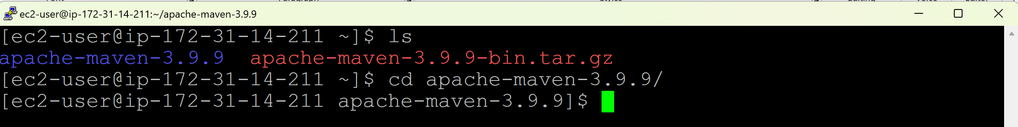

Check for the files in apache folder

ls



Go to bin folder

cd bin





Now, take the path

pwd

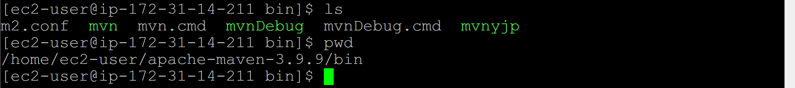

**Step 4: Set the environment variables or path**

sudo vim /etc/profile (To set the path in profile file)



Add the following lines at the end of the file

export M2_HOME=/home/ec2-user/apache-maven-3.9.9

export PATH=$M2_HOME/bin:$PATH

Save and exit the file.

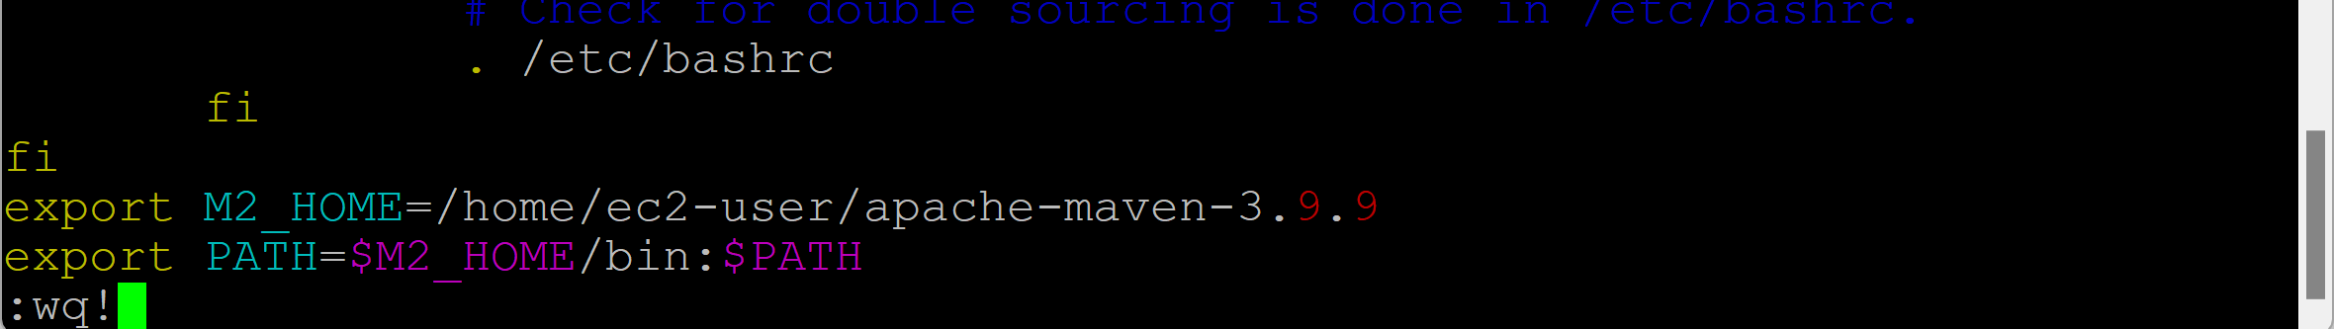

Then reload the environment variables

source /etc/profile

mvn --version

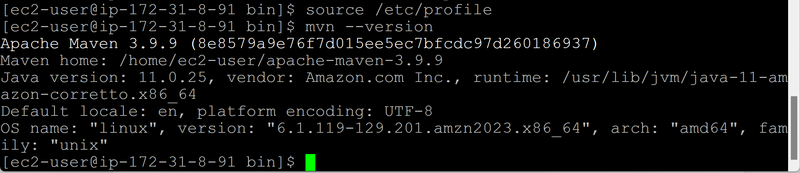

**Maven installation on Debian family (Ubuntu):**

**Step 1: Install Java**

**Update the Package Repository**

sudo apt update (To ensure the package repository is updated)

**Install OpenJDK 11**

sudo apt install openjdk-11-jdk -y

**Verify the installation**

java -version

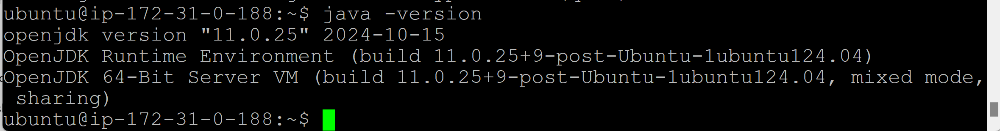

**Step 2: Download Maven**

**Update the Package index**

sudo apt update

sudo apt upgrade -y

**Install OpenJDK 11**

Go to Browser > Type Apache Maven download > Go to the first link > Copy the first link address

sudo wget <https://dlcdn.apache.org/maven/maven-3/3.9.9/binaries/apache-maven-3.9.9-bin.tar.gz>

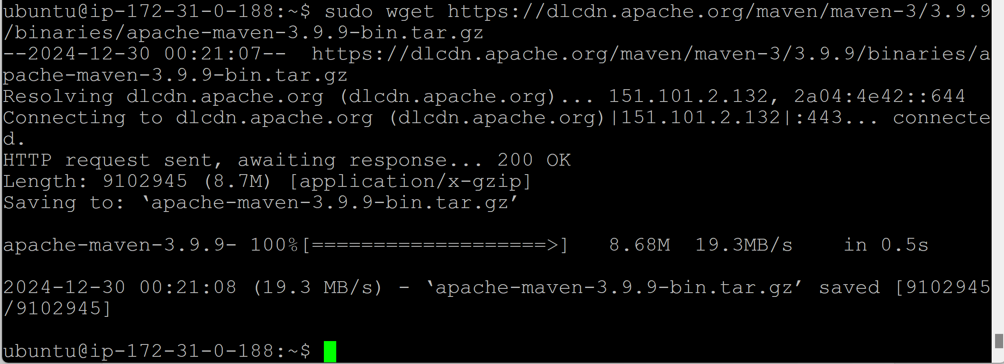

**Step 3: Extract tar file**

tar xvf apache-maven-3.9.9-bin.tar.gz (To extract the tar file)

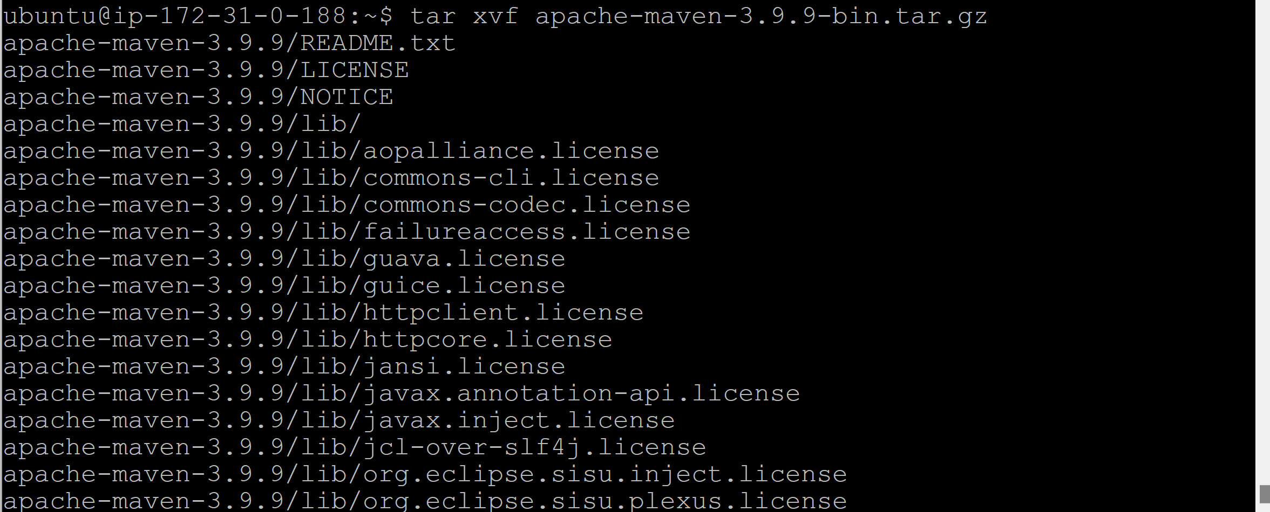

ls (To check, if tar file is extracted)



Go to the apache folder

cd apache-maven-3.9.9/



Check for the files in apache folder

ls



Go to bin folder

cd bin



Now, take the path

pwd



**Step 4: Set the environment variables or path**

sudo vim /etc/profile (To set the path in profile file)



Add the following lines at the end of the file

export M2_HOME=/home/ubuntu/apache-maven-3.9.9

export PATH=$M2_HOME/bin:$PATH

Save and exit the file.



Then reload the environment variables

source /etc/profile

mvn --version

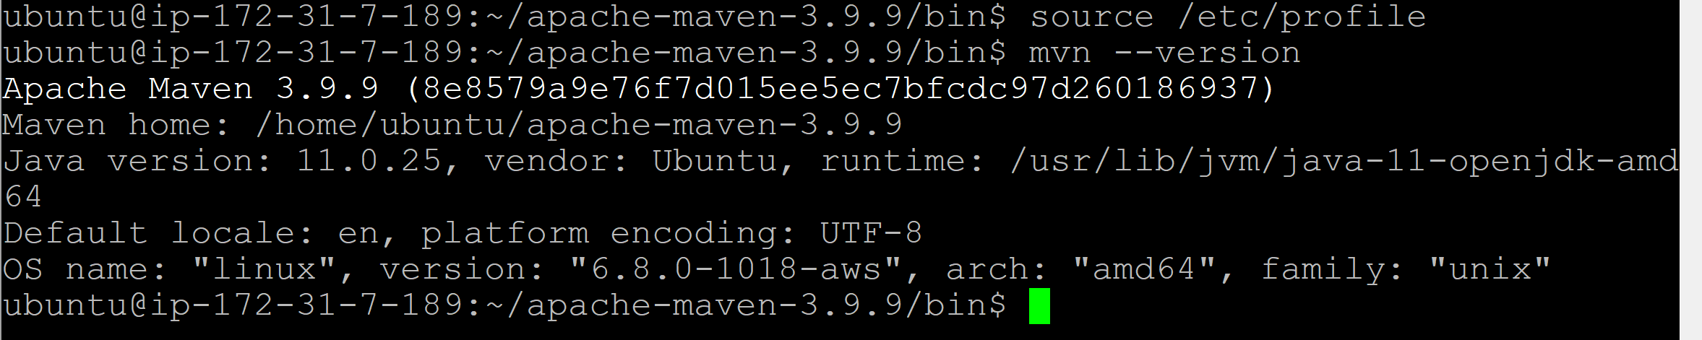

**Maven installation on Windows server:**

**Step 1: Download & Install Java**

Go to <https://adoptium.net/temurin/archive/?version=11> > Click on Binary JDK of Windows x64 > File will be downloaded > Go to Downloads > Copy and Paste it in C drive > Extract the Zip file > Open the folder > Cut and Paste the folder in C drive > Copy the Jdk path (C:\jdk-11.0.25+9) > Windows > Search for ‘View advanced system settings’ > Environment variables > Click on ‘New’ of System variables > Enter Variable name = JAVA_HOME > Variable value = Paste the copied Jdk path (C:\jdk-11.0.25+9) > Click on OK > Select the Path of ‘System variables’ > Click on Edit > Click on ‘New’ > Enter “%JAVA_HOME%\bin” > Click on OK > Click on OK > Click on OK

To check, if Java is installed:

Open command prompt > java -version

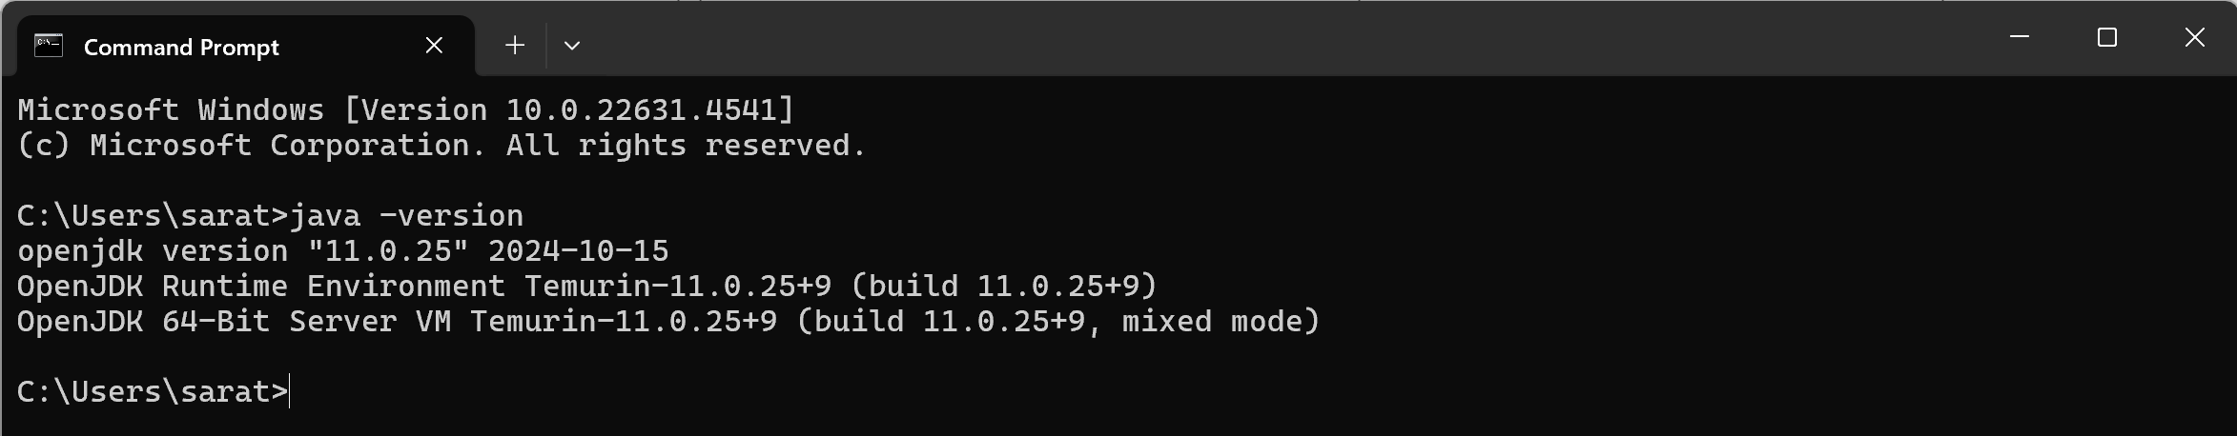

**Step 2: Download & Install Maven**

Go to Browser > Type Apache Maven download > Go to the first link > Copy the first link address > Click on the Binary zip > File will be downloaded > Go to Downloads > Copy and Paste it in C drive > Extract the Zip file > Open the folder > Cut and Paste the folder in C drive > Copy the Maven path (C:\apache-maven-3.9.9) > Windows > Search for ‘View advanced system settings’ > Environment variables > Click on ‘New’ of System variables > Enter Variable name = M2_HOME > Variable value = Paste the copied Maven path (C:\apache-maven-3.9.9) > Click on OK > Select on Path of ‘System variables’ > Click on Edit > Click on ‘New’ > Enter “%M2_HOME%\bin” > Click on OK > Click on OK > Click on OK

To check, if maven is installed:

Open command prompt > mvn --version

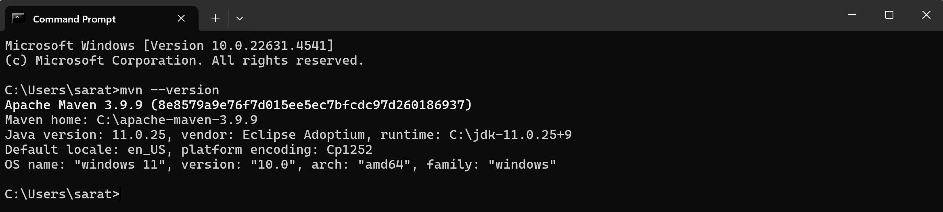

**Day_04 (Compile/Build a Java application)**

* When we compile/build any java-based application, we get one of the below artifacts:
  + Jar
  + War
  + Ear
* After writing the code, Developers will host it in Github.
* We need to get the project/repository from Github to the local server (where Git, Java, Maven must be installed)
  + git clone <HTTPS or SSH protocol url>

**Using Linux server:**

**Step 1: Make sure you have a repository of the project in Github.**

**Copying the repository/project from one account into your account**

Login to your Github (github.com) > Add account name (where repository/project is available) to the url (github.com/VTechnologies-NagireddyVenna) > Click on the ‘Repositories’ tab > Click on the repository that you wanted > Click on Fork > Click on ‘Create fork’ > Go to ‘Your repositories’ > You should be able to see the copied repository/project in your account.

Click on the repository > Code > Copy the HTTPS protocol url

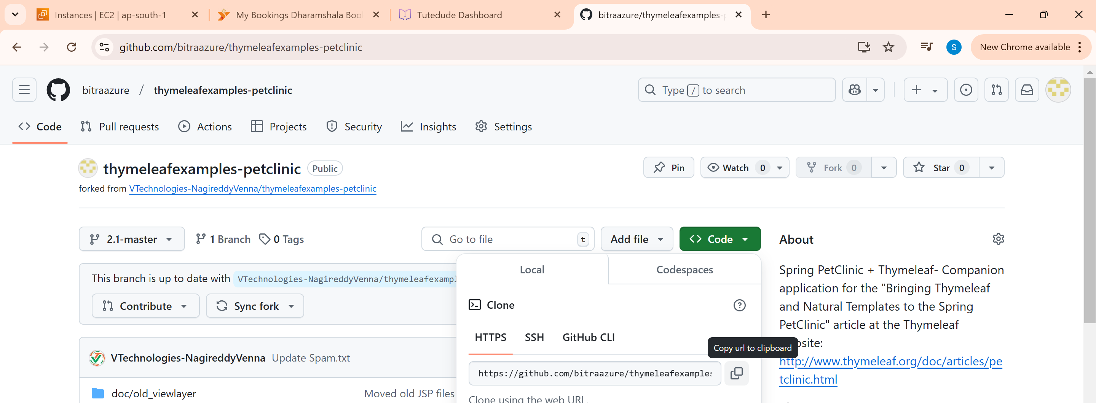

**Step 2: Make sure you have Git, Java and Maven are installed on your Linux server**

sudo yum install git -y (To install git)

git --version

java -version

mvn --version

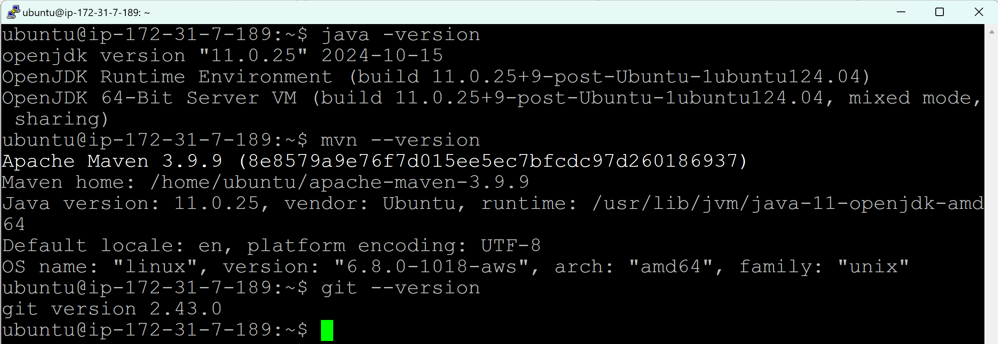

**Clone the repository from Github into local/build server**

git clone <https://github.com/bitraazure/thymeleafexamples-petclinic.git>

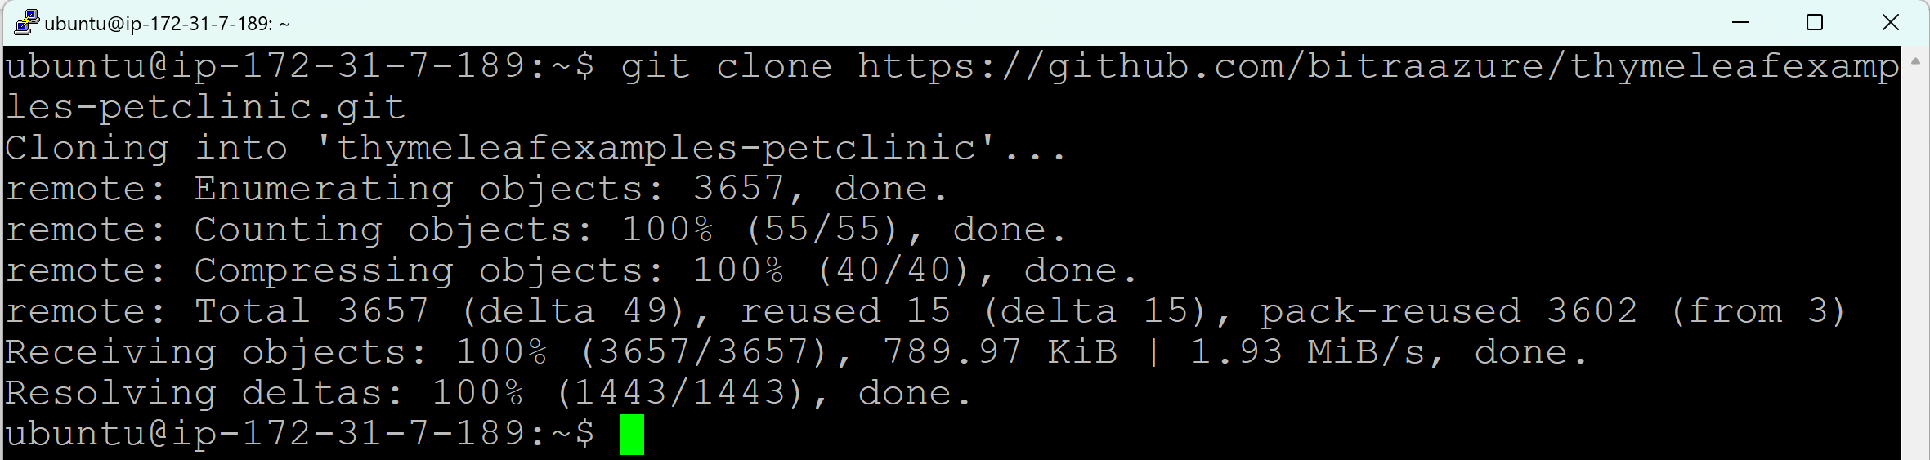

ls



* We know all the git operations can be performed in a repository.
* Similarly, maven operations also can be performed in a repository.
* A repository must contain .git
* For Maven to build a project, additionally it must contain POM.xml file and src folder.

**Move to the repository:**

cd [thymeleafexamples-petclinic](https://github.com/bitraazure/thymeleafexamples-petclinic)

ls -a

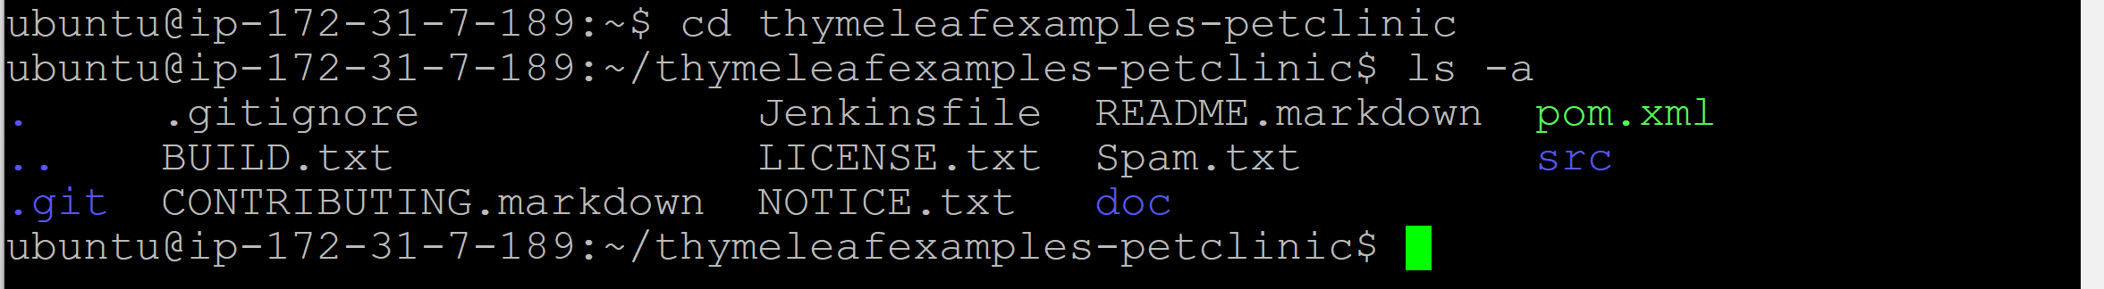

It must contain POM.xml, src folder and .git folder

**Why src folder is required?**

Maven must follow a standard directory structure where it contains src folder and code will be written in src folder.

**Step 3: To compile/build a project and to create an artifact**

mvn package

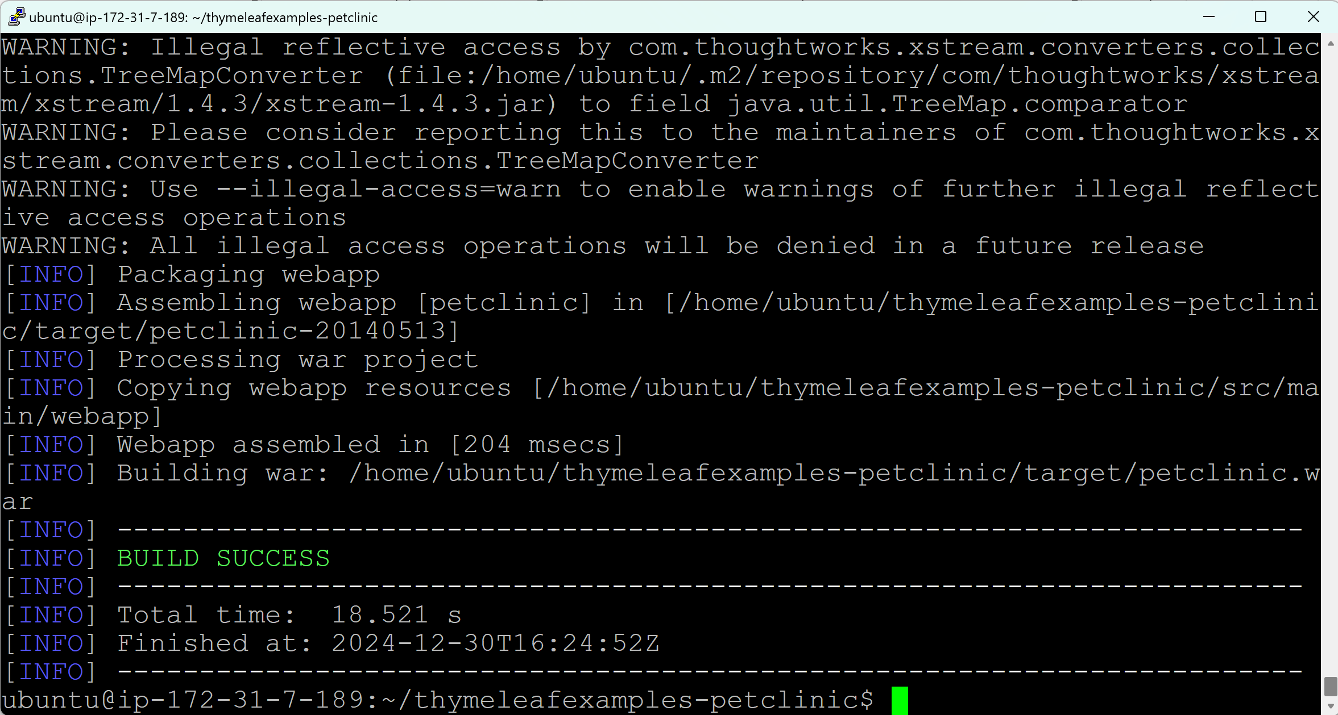

ls

target folder will be created when we compile/build a project and artifact is created.

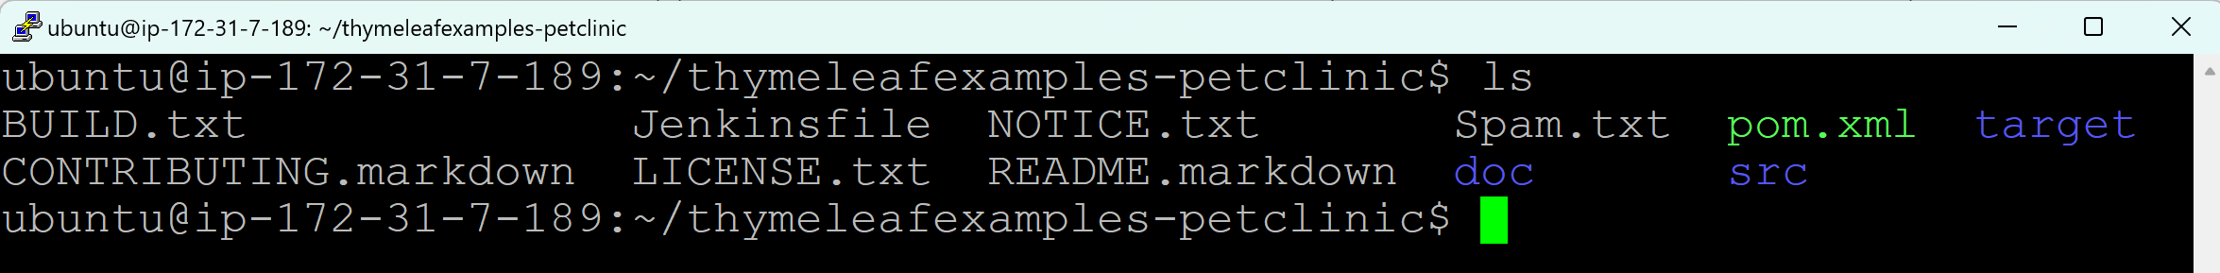

**Move to the target folder**

cd target/

ls

You can see petclinic.war file.

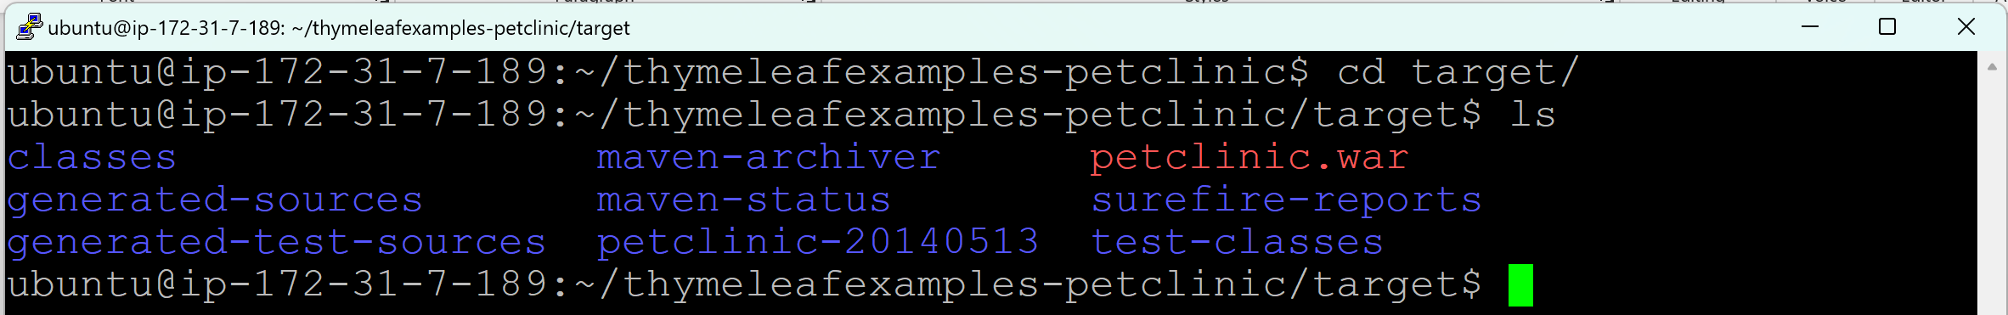

**Using Windows server:**

**Step 1: Make sure you have a repository of the project in Github.**

**Copying the repository/project from one account into your account**

Login to your Github (github.com) > Add account name (where repository/project is available) to the url (github.com/VTechnologies-NagireddyVenna) > Click on the ‘Repositories’ tab > Click on the repository that you wanted > Click on Fork > Click on ‘Create fork’ > Go to ‘Your repositories’ > You should be able to see the copied repository/project in your account.

Click on the repository > Code > Copy the HTTPS protocol url



**Step 2: Make sure you have Git, Java and Maven are installed on your Linux server**

Open Git bash here

git --version

java -version

mvn --version

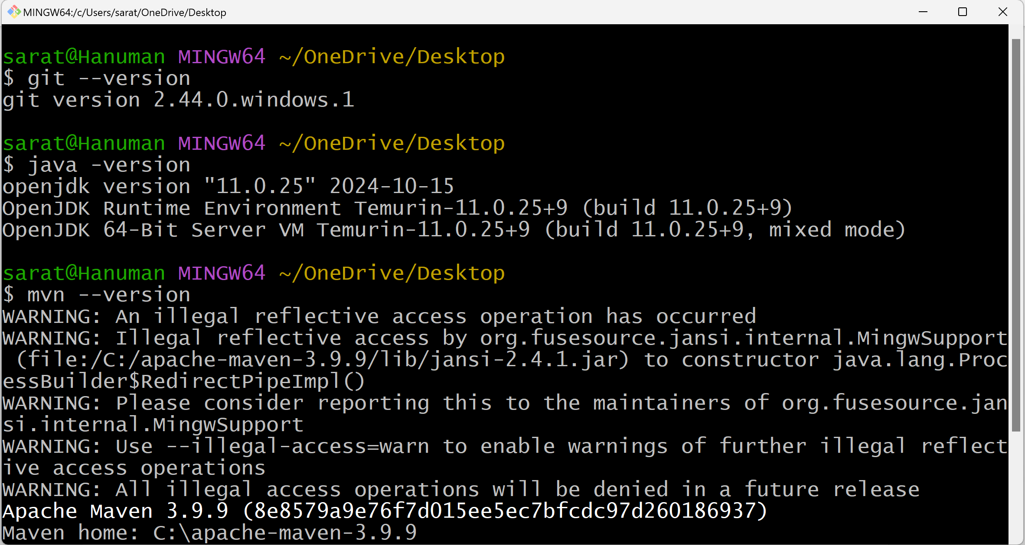

**Clone the repository from Github into local/build server**

git clone <https://github.com/bitraazure/thymeleafexamples-petclinic.git>

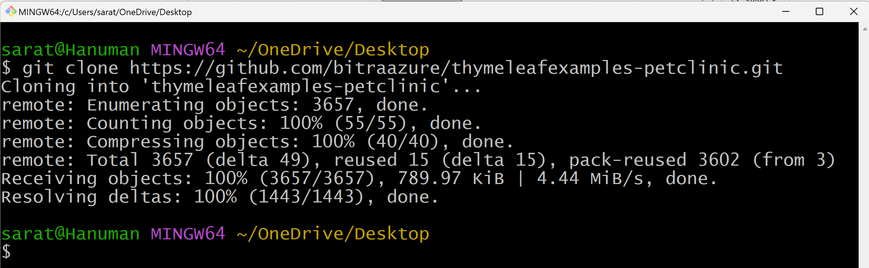

ls

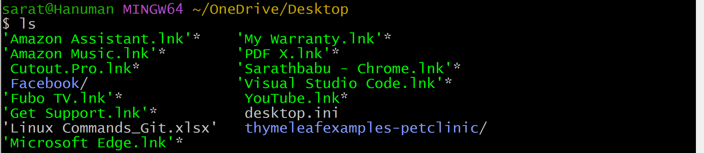

**Move to the repository:**

cd [thymeleafexamples-petclinic](https://github.com/bitraazure/thymeleafexamples-petclinic)/

ls -a

It must contain POM.xml, src folder and .git folder

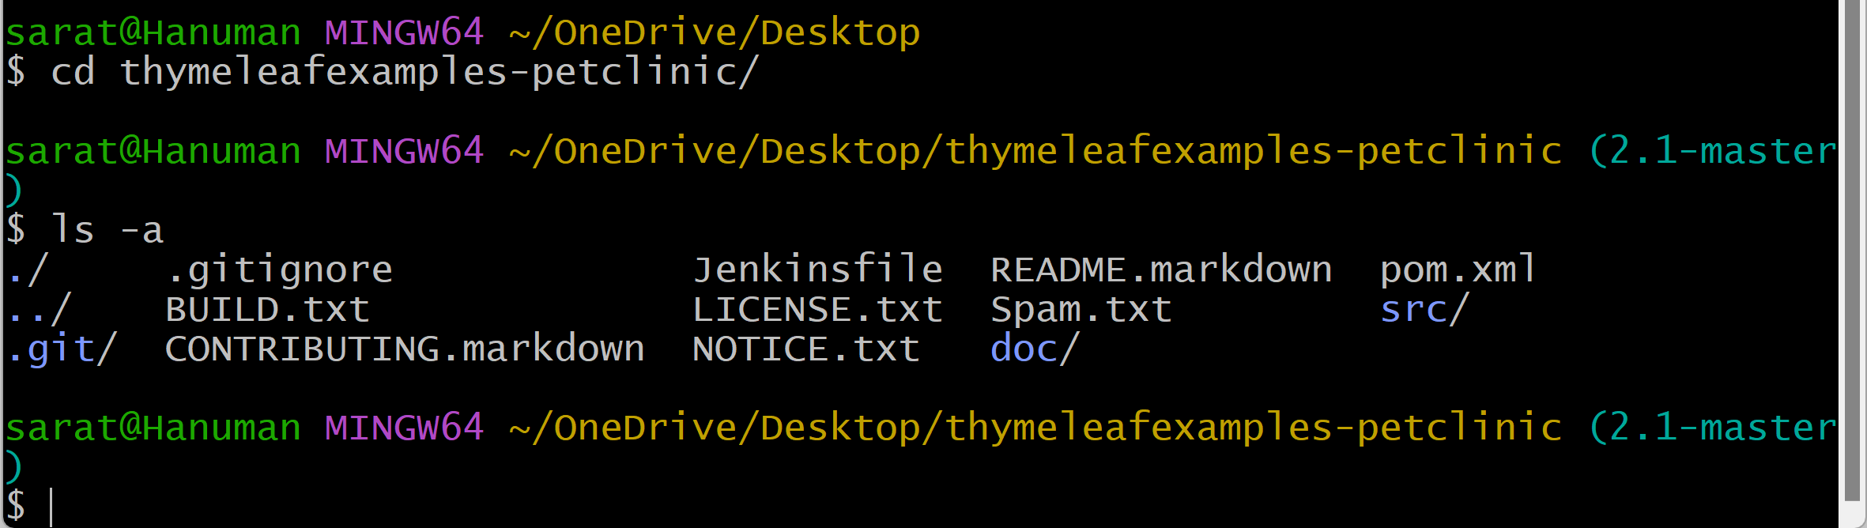

**Step 3: To compile/build a project and to create an artifact**

mvn package

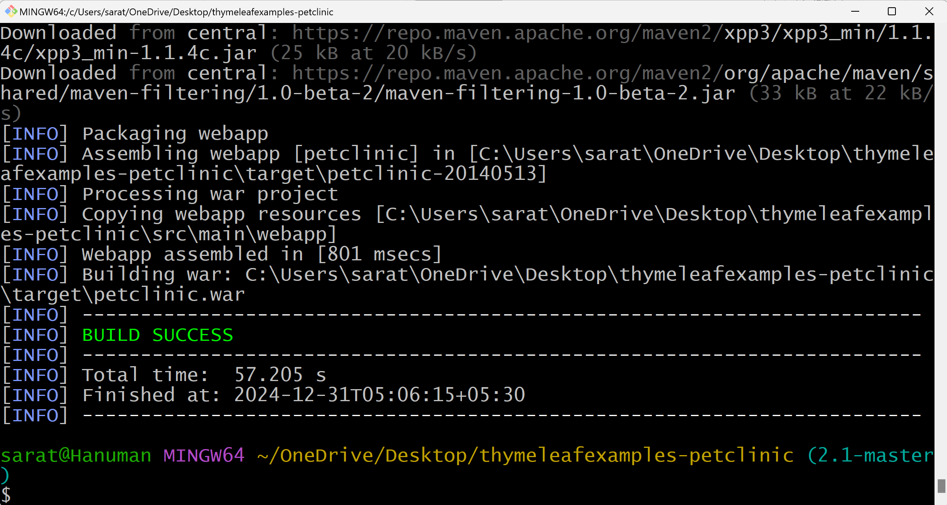

ls

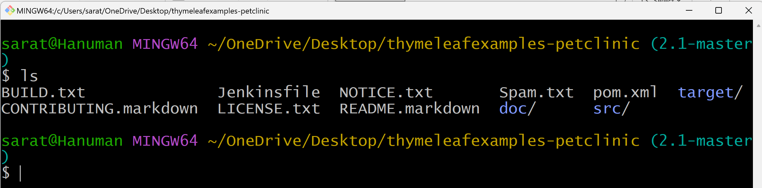

**Move to the target folder**

cd target/

ls

You can see petclinic.war file.

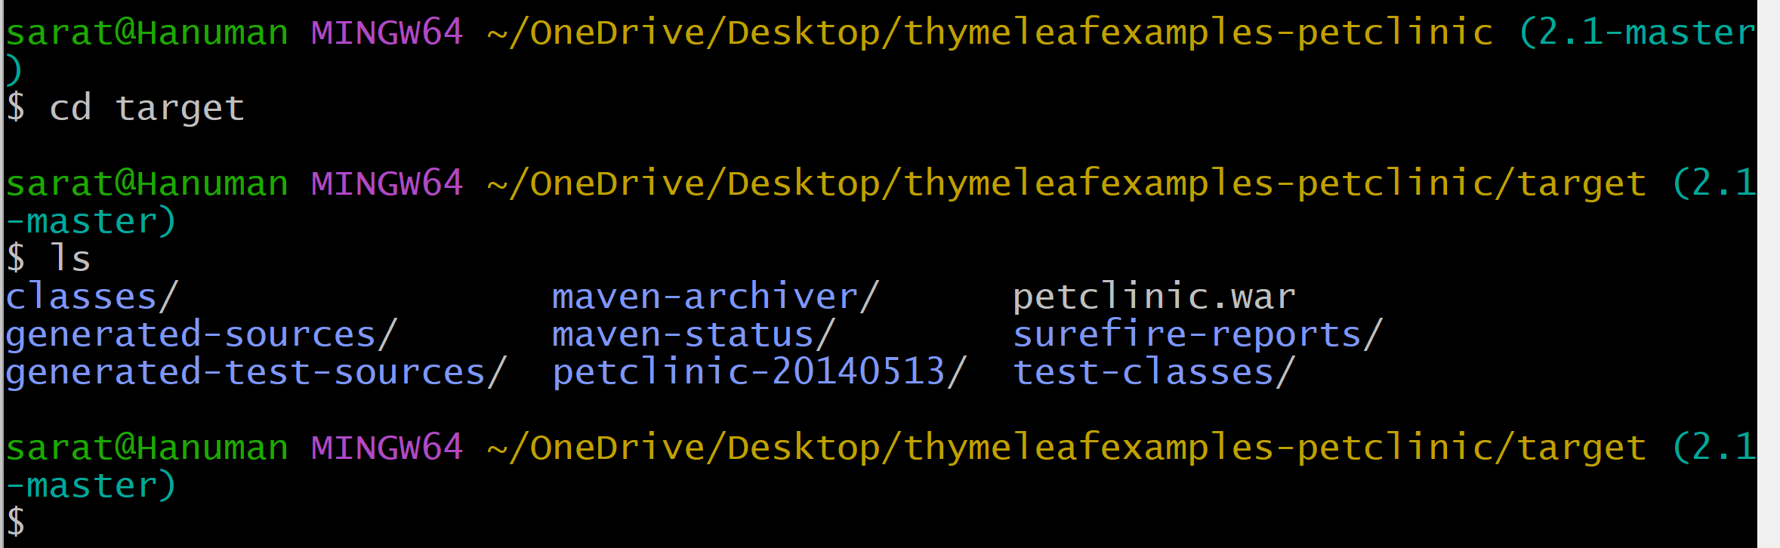

**Day_05 (Maven Life Cycle/Goals/Phases)**

Maven build lifecycle and phases are designed to be sequential or cumulative

* mvn clean
* mvn validate
* mvn compile
* mvn test
* mvn package
* mvn verify
* mvn install
* mvn deploy

**mvn clean: (Removes the target folder)**

* It ensures that any previously built artifacts (which contains compiled classes, JARs and other build artifacts) are removed before starting a fresh build.
* Typically run before a new build to ensure that old artifacts don’t interfere with the current build.
* It is not needed to run the command, when you build/compile a project for the first time.
* It is recommended to run the command, when you build/compile a project the second time.

**mvn validate: (Verify the project’s structure and configuration (pom.xml))**

* Validates the project’s structure and configuration (pom.xml) before the actual build starts.

**mvn compile: (Creates the target folder)**

* Complies the source code of the project located in src/main/java into bytecode.
* We have 2 folders in src folder
  + main
  + test
* main folder contains the java code
  + When we run **mvn compile** command, xxxx.java will be converted to xxxx.class
* test folder contains the test cases

**mvn test:**

* Runs the unit tests using a testing framework like Junit or TestNG.
* To ensure that your code passes all unit tests.

**mvn package: (Artifacts will be stored in the target folder)**

* Packages the compiled code into a distributable format like JAR, WAR, or EAR.
  + All xxxx.class files will form as a JAR, WAR, or EAR
  + All artifacts will be stored in the target folder.

**mvn verify:**

* Runs any checks on the results of integration tests to ensure the quality of the project.
* Often used to perform additional validation on the build artifacts.

**mvn install: (Artifacts will be stored in .m2 folder)**

* Installs the packaged artifact into the local Maven repository (usually located in ~/.m2/repository)
* This repository is not for source code, it is for artifacts.
* Usually, we have 3 types of repositories:
  1. Local Repository (Artifacts will be stored in .m2 folder)
  2. Remote Repository (Nexus)
  3. Central Repository (Maven website)

**mvn deploy: (Artifacts will be stored in Nexus)**

* Deploys the artifact to a remote repository for sharing with other developers or projects.

**Exercise:**

Open the Git bash here for thymeleafexamples-petclinic

ls



mvn clean (To remove/delete the target folder and ensure that old artifacts don’t interfere with the current build)

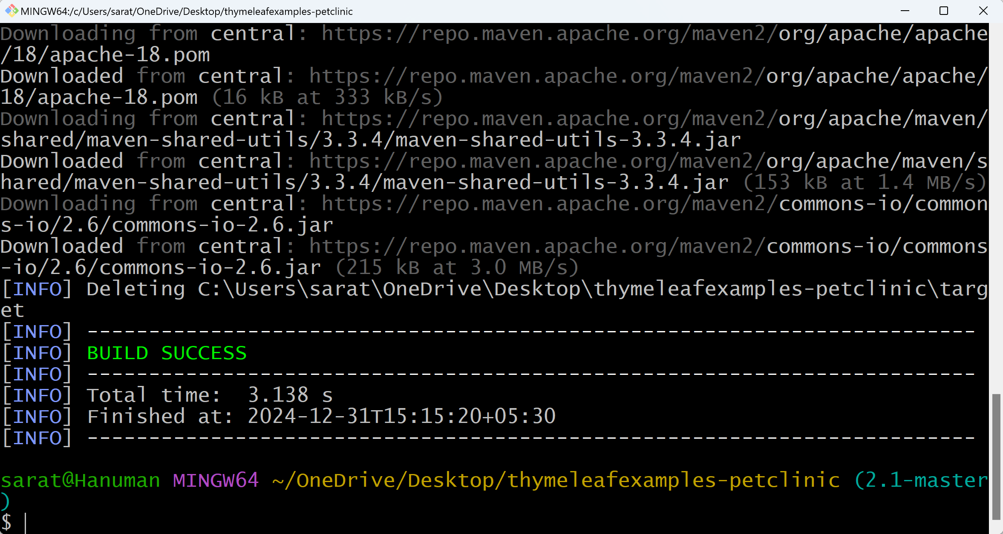

ls (To check, if target folder is deleted)

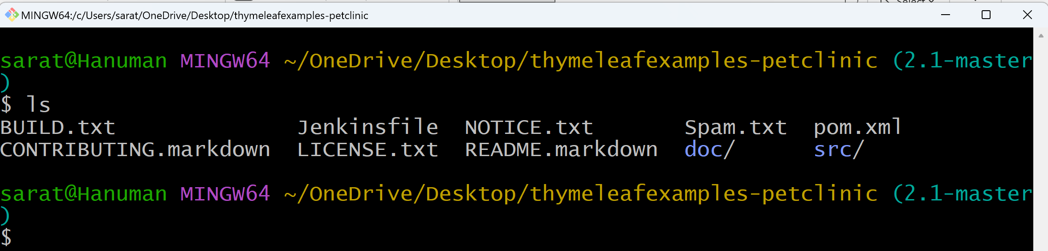

mvn validate (Check for the project structure and configuration (pom.xml))

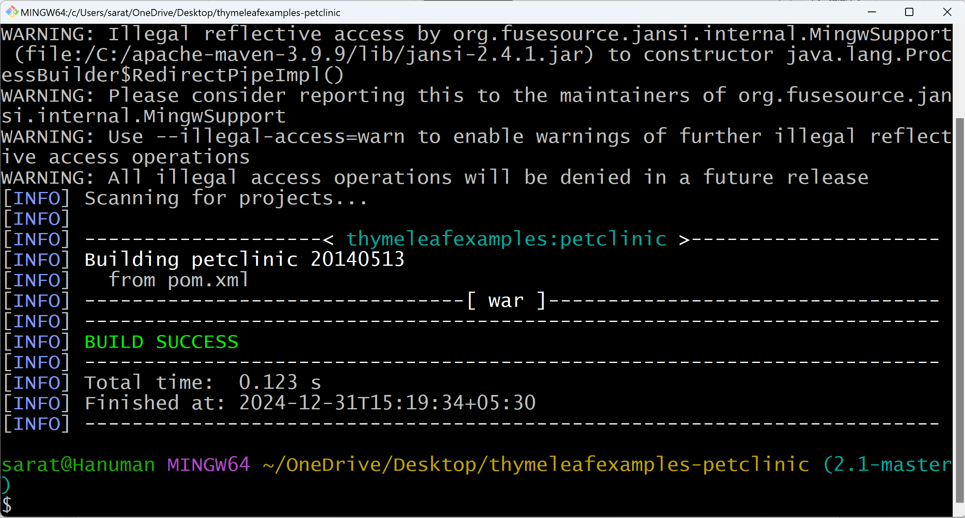

mvn compile (Creates empty target folder)

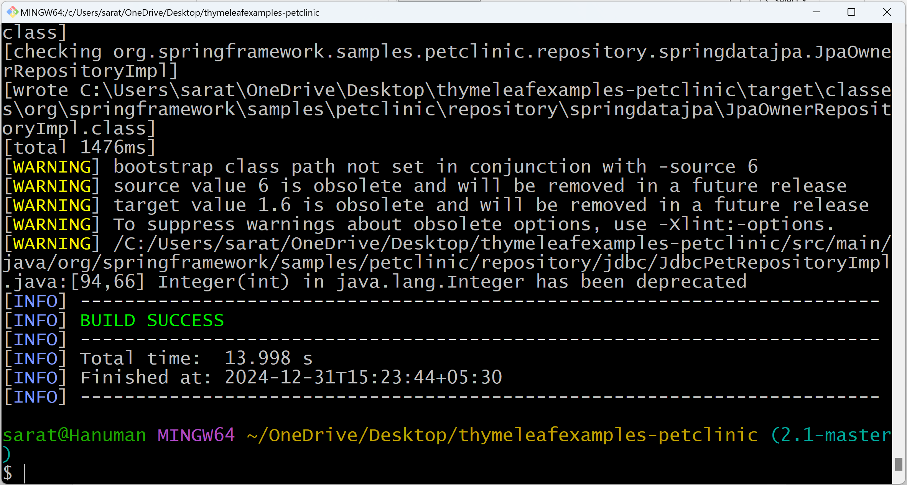

ls (Check, if target folder is created)

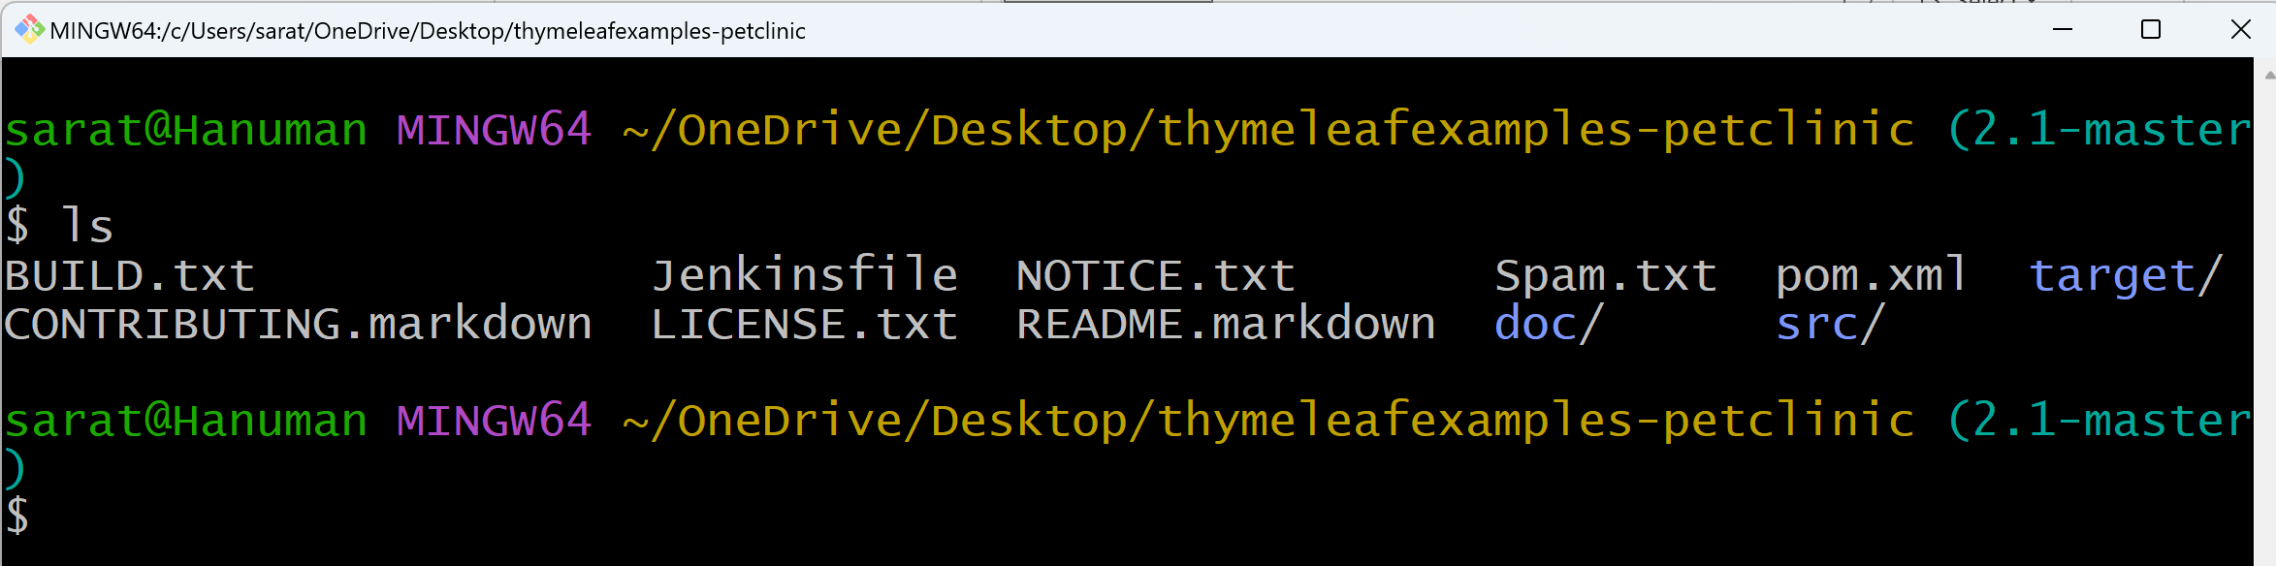

mvn install

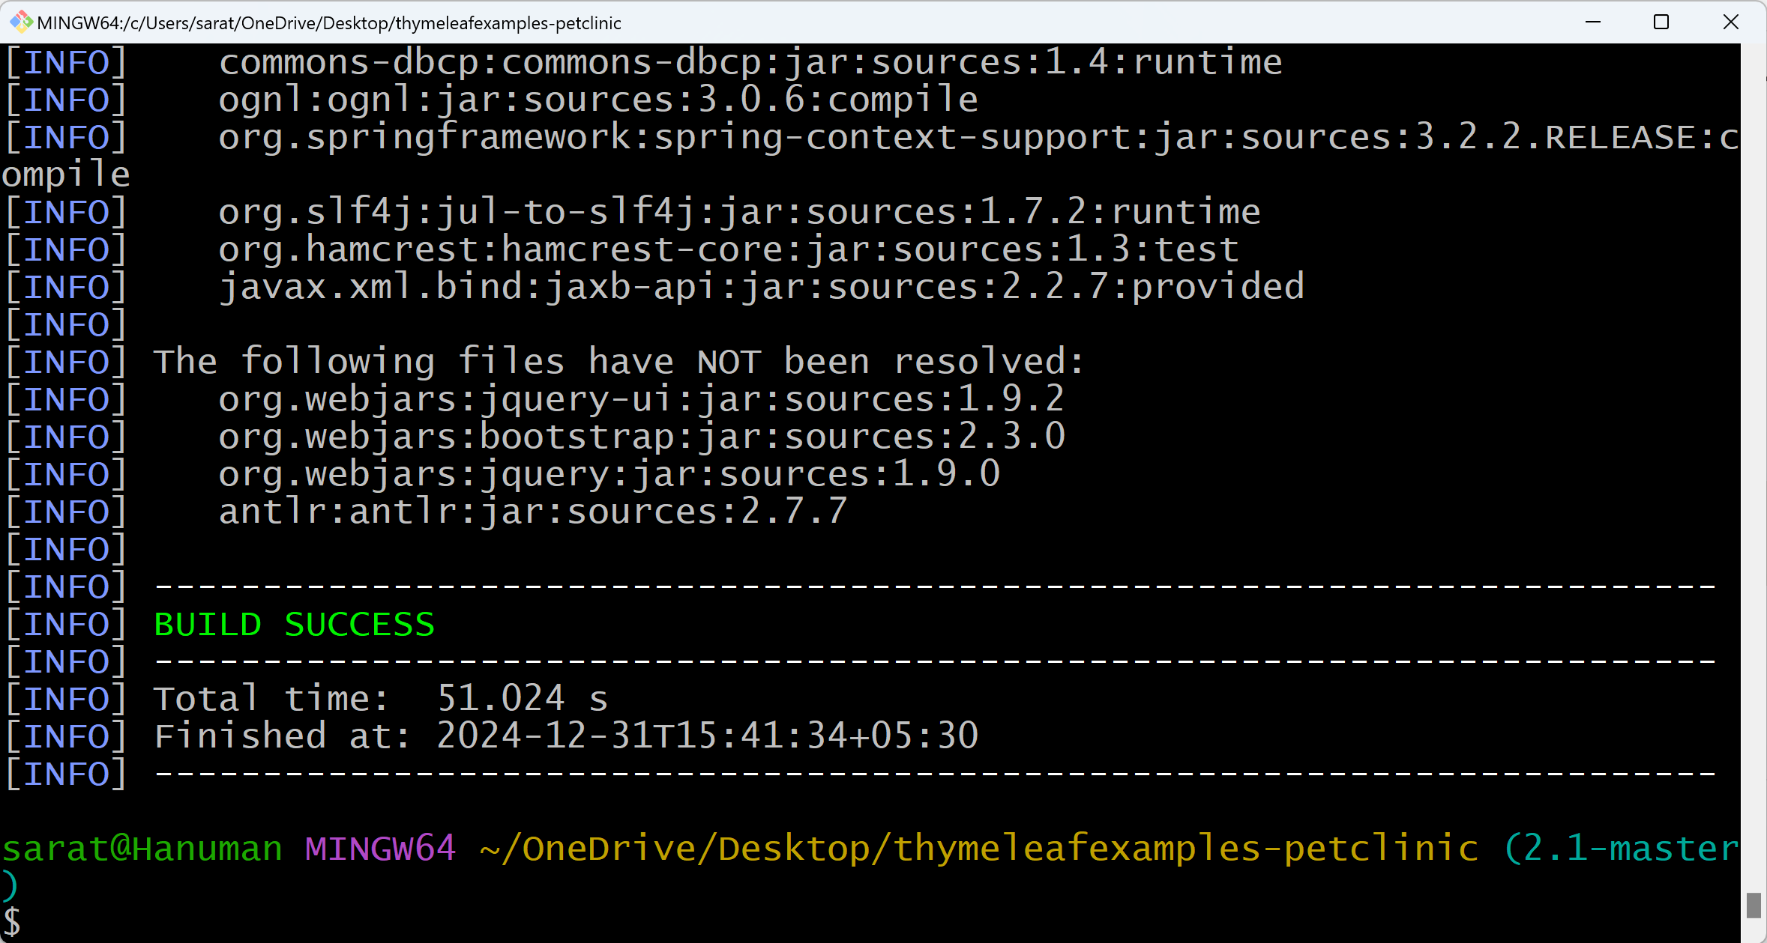

ls

Move to the target folder

cd target/

ls

When you run mvn install command, it automatically runs mvn package. Hence, we can see target folder.

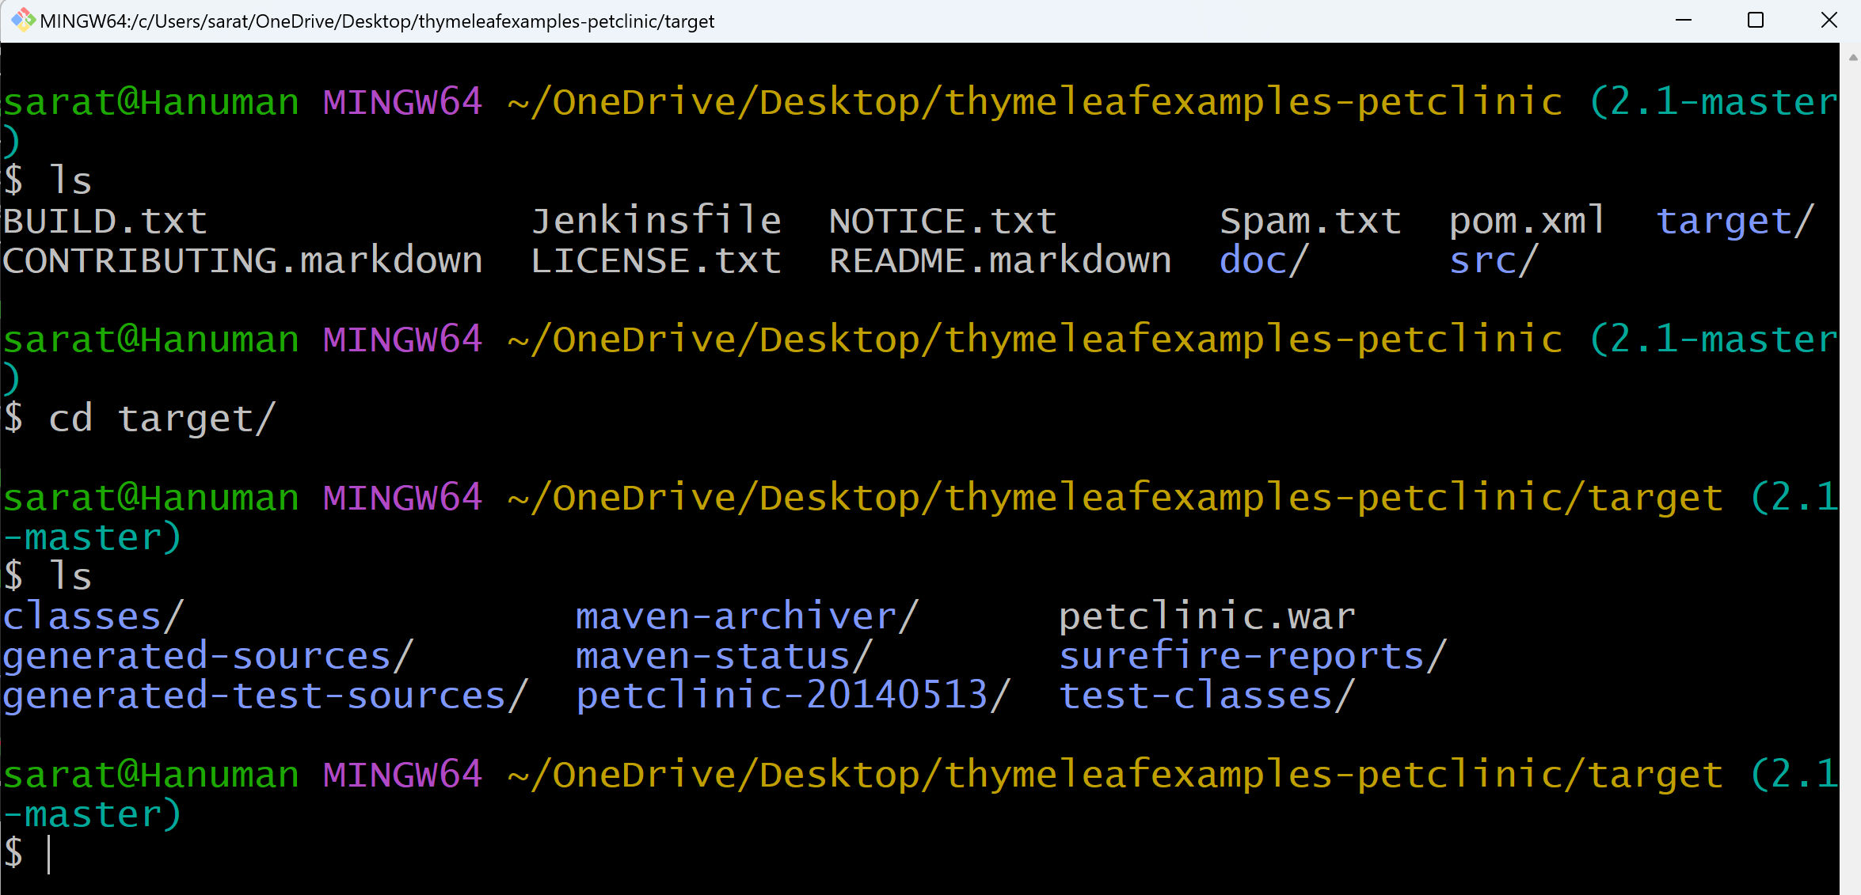

Move to local repository (Home directory)

cd –

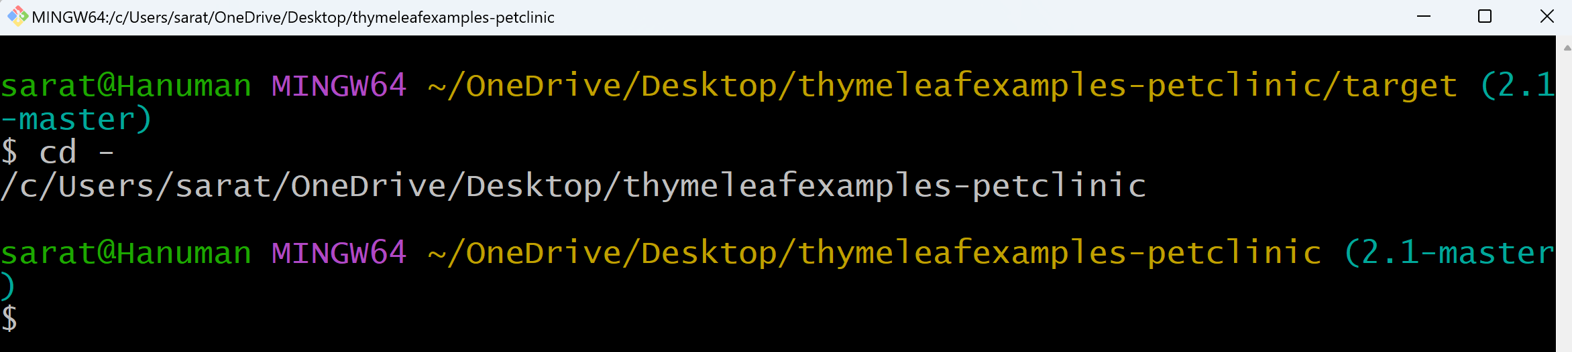

cd

ls -a

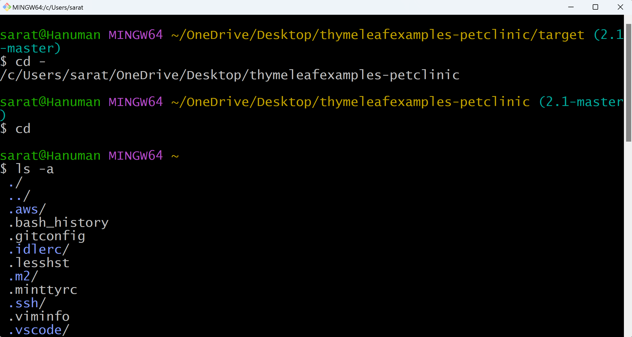

cd .m2/

ls -a

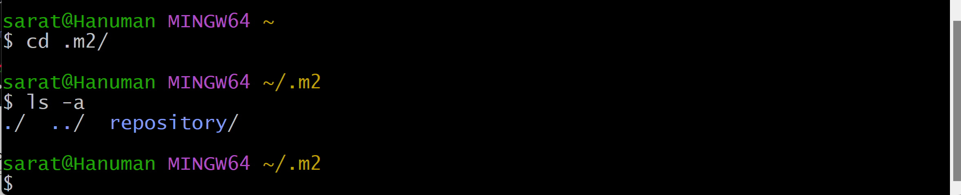

cd repository/

ls -a

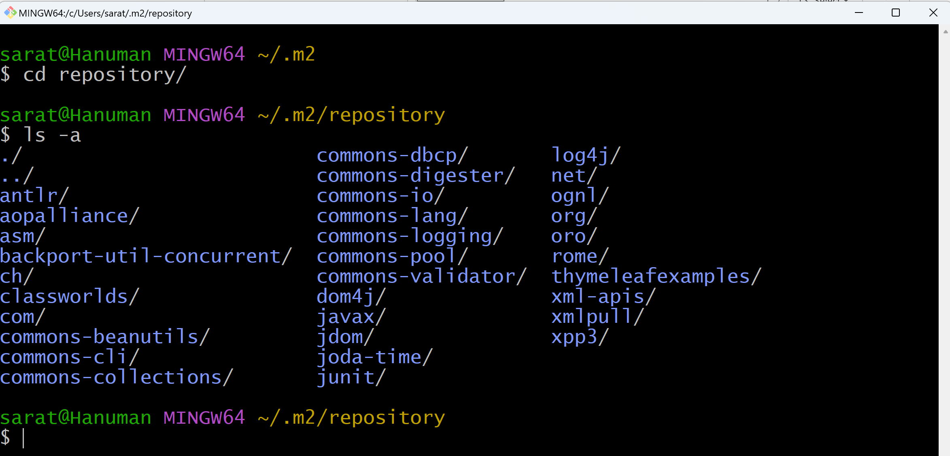

cd thymeleafexamples/

ls -a

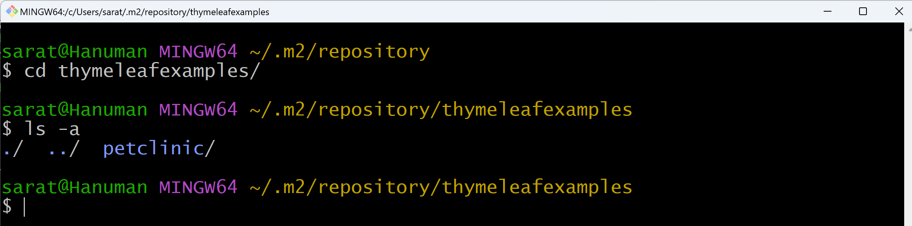

cd petclinic/

ls -a

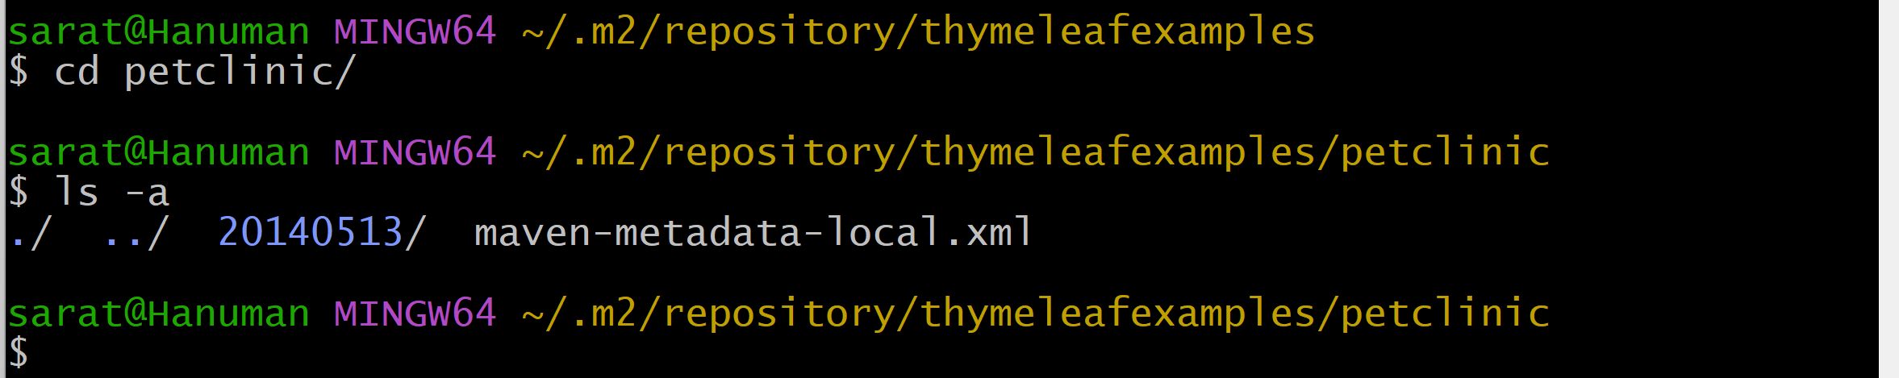

cd 20140513/

ls -a

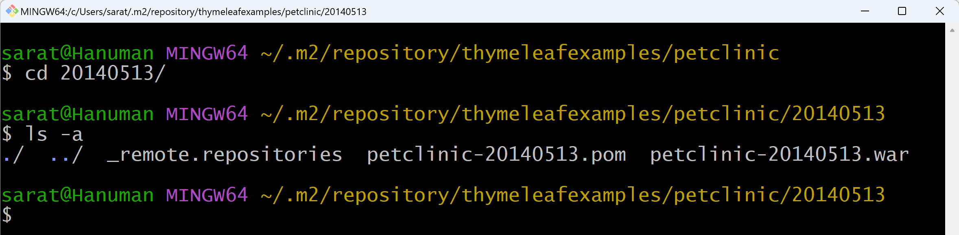

mvn deploy will be discussed & covered in upcoming classes (Once Nexus is setup).

**Day_06 (Maven project creation)**

* To compile/build a project through Maven, two major things required:

1. src folder
2. pom.xml

* When we create a Maven project, src folder and pom.xml will be created automatically.
* src folder contains main and test folders.
* main folder contains all java files.
* test folder contains test cases for all java files.

**Open Git bash here**

mvn archetype:generate

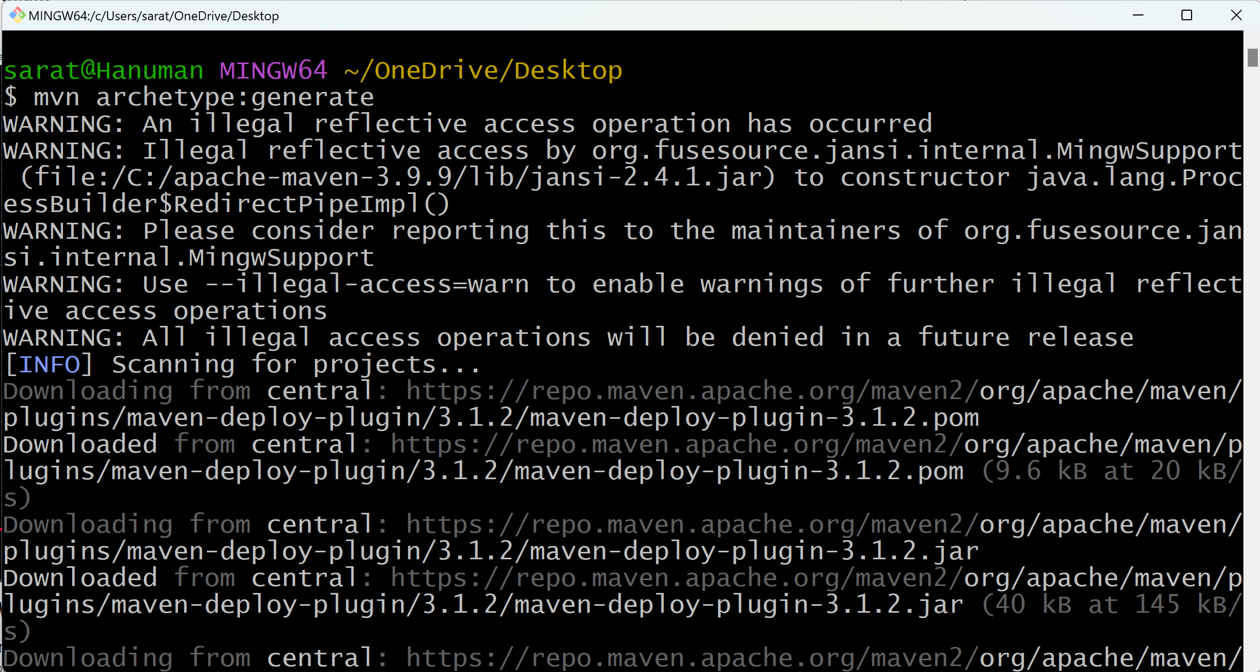

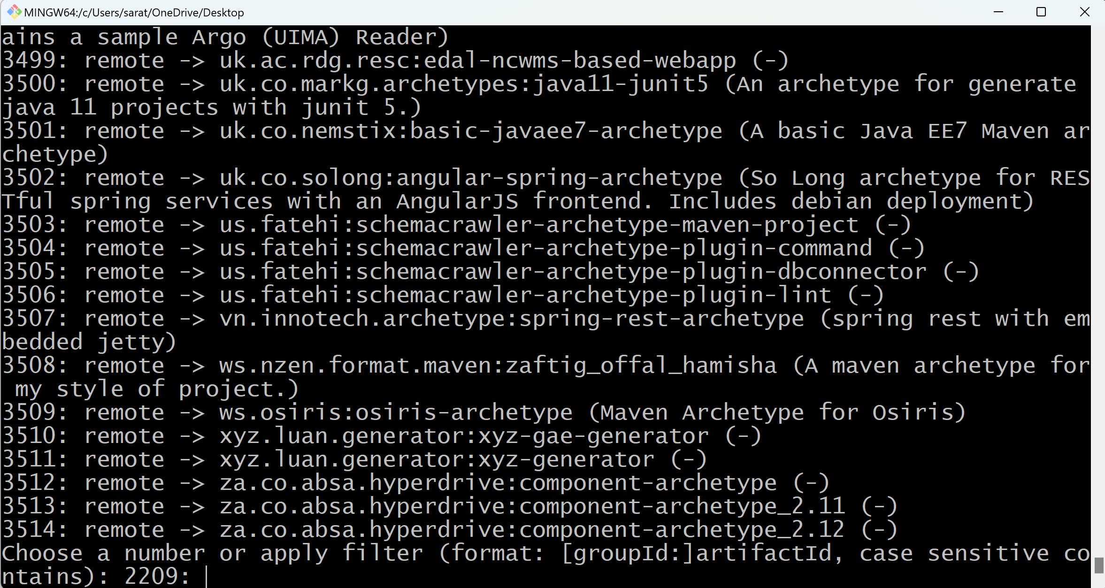

Enter the default groupId (2209)



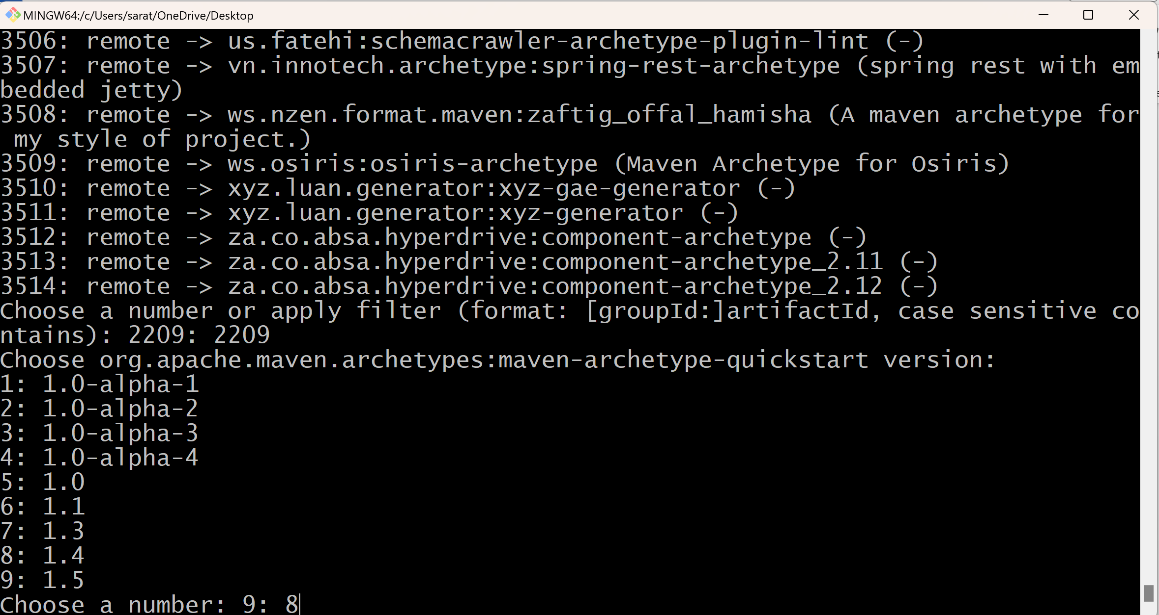

Choose a maven version (8)

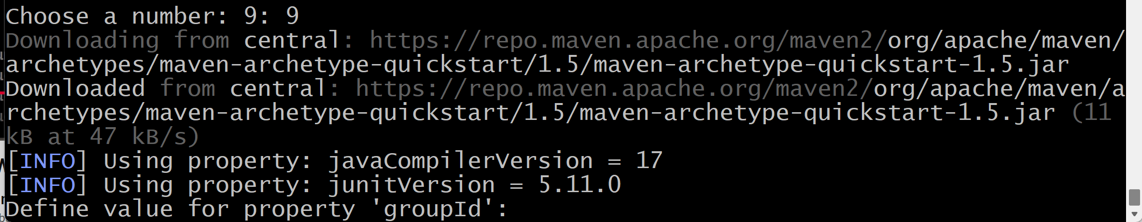

Enter groupId (com.example.banking)



Enter artifactId (vetch)



Enter version (1.0-SNAPSHOT)



Enter package (com.example.banking)



Enter Y

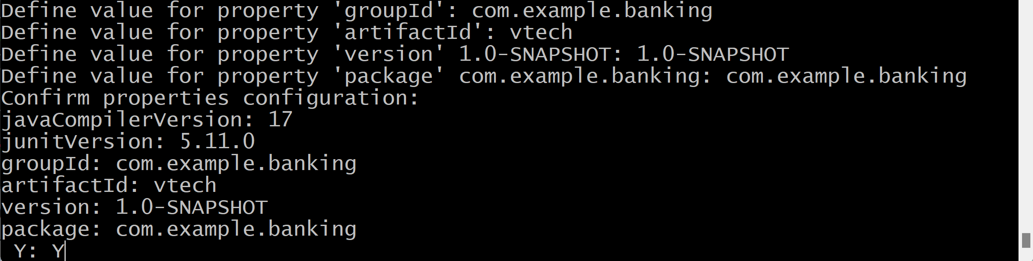

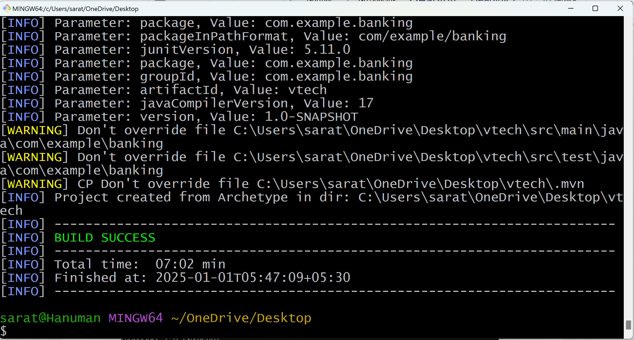

vtech folder gets created

ls

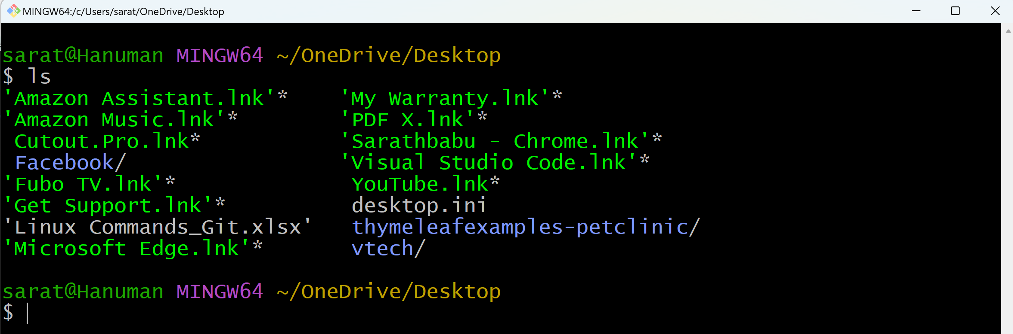

Move to vtech folder and check for the files/folders

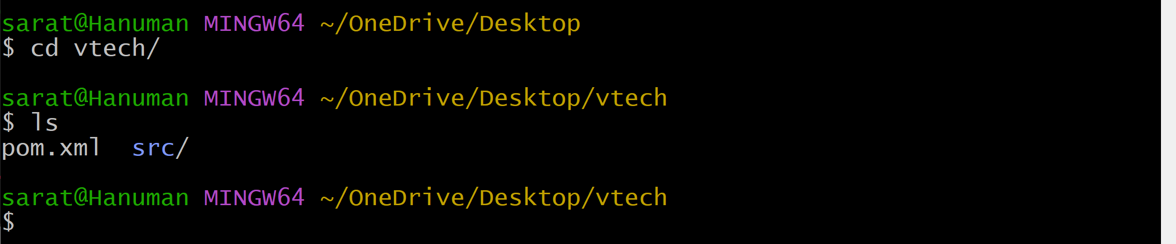

Move to src folder and check for the files/folders

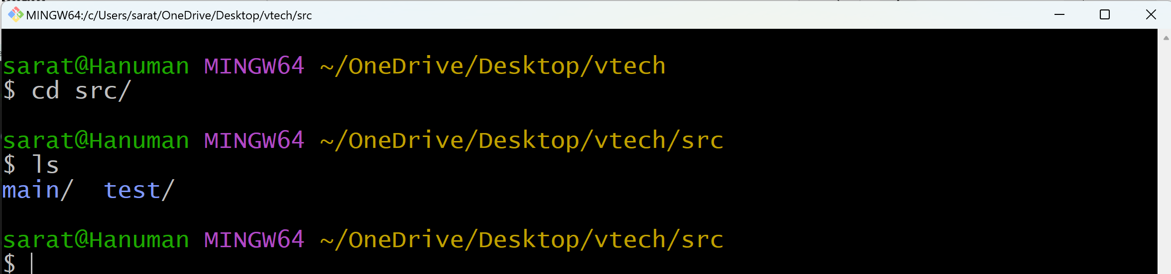

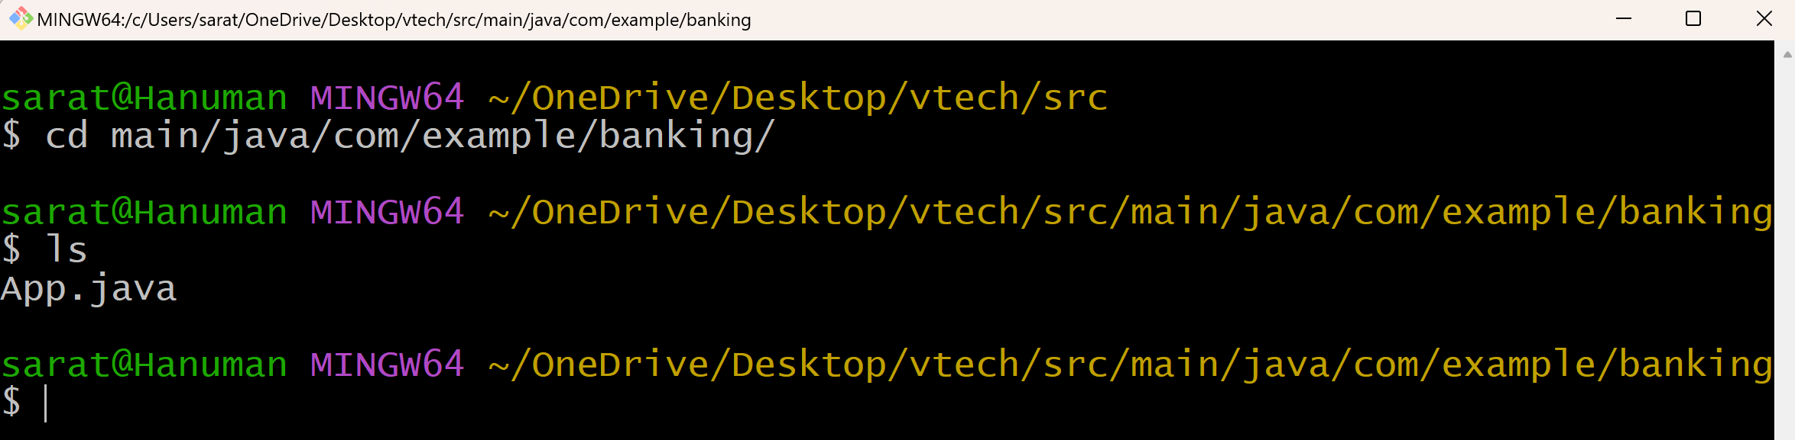

**Now build/compile this application**

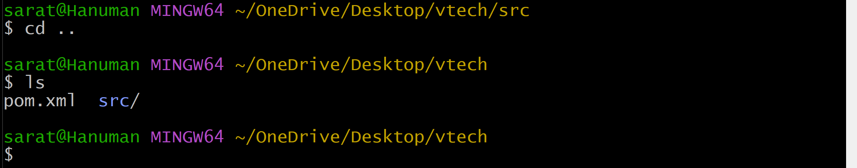

mvn package to build/compile the application.

When we execute the command package:

1. Run the test cases automatically
2. target folder gets created.

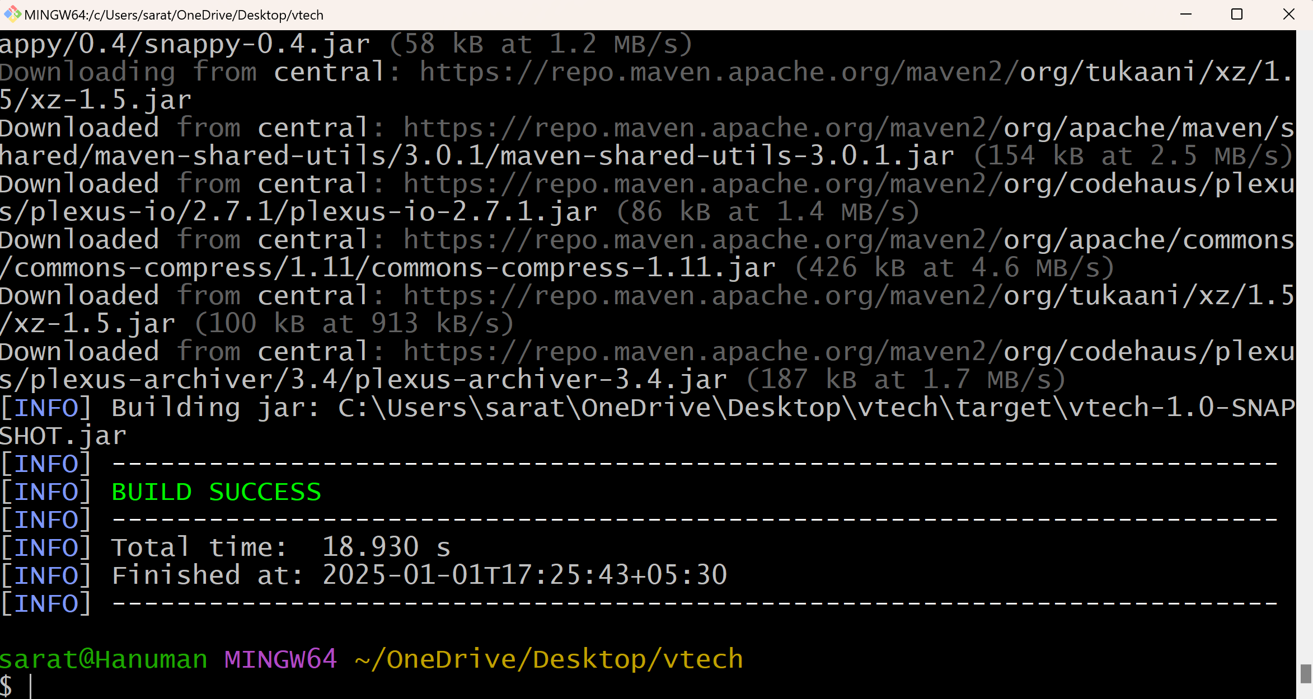

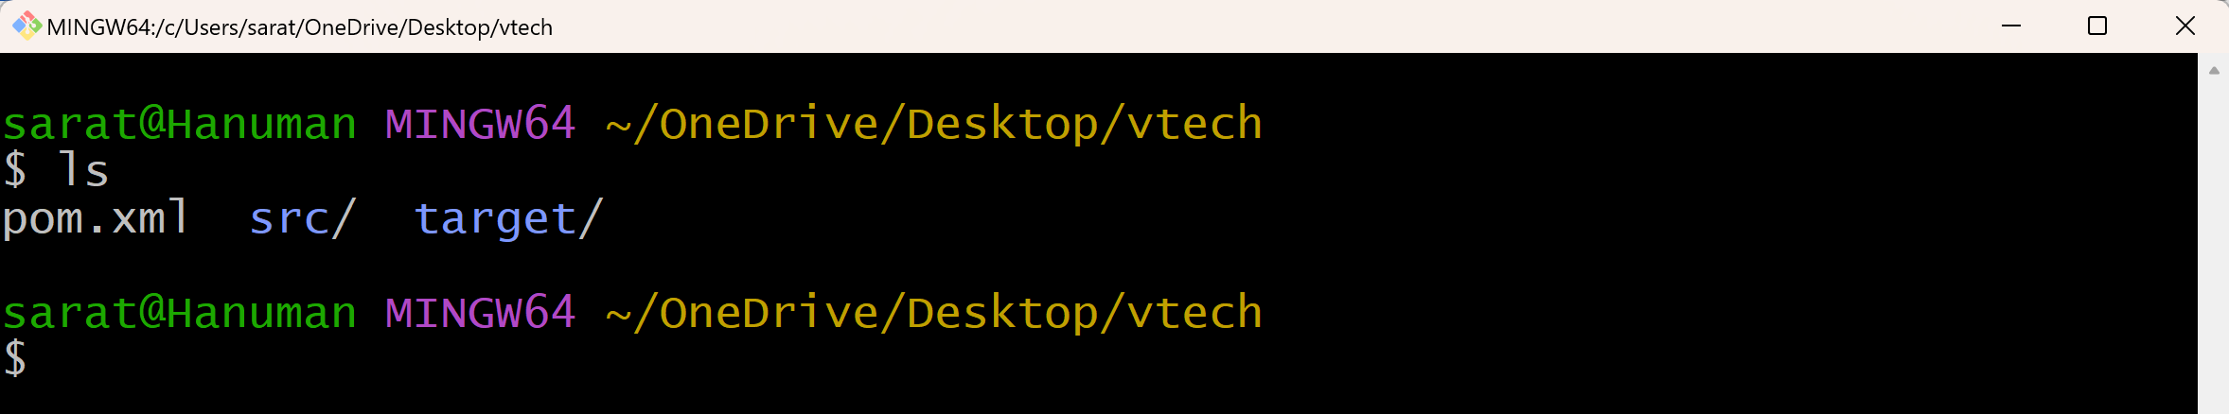

**Check for the test cases:**

Move to src folder

cd src/

ls

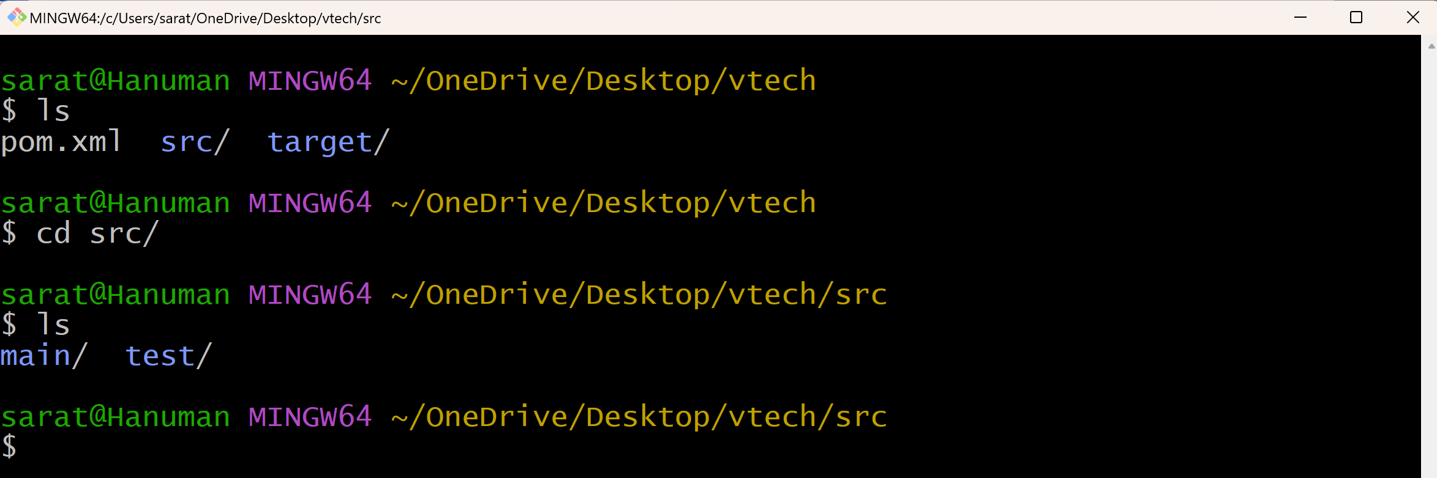

Move to main folder to check, to check, if App.java is created

cd main/

cd java/

cd com/

cd example/

cd banking/

ls

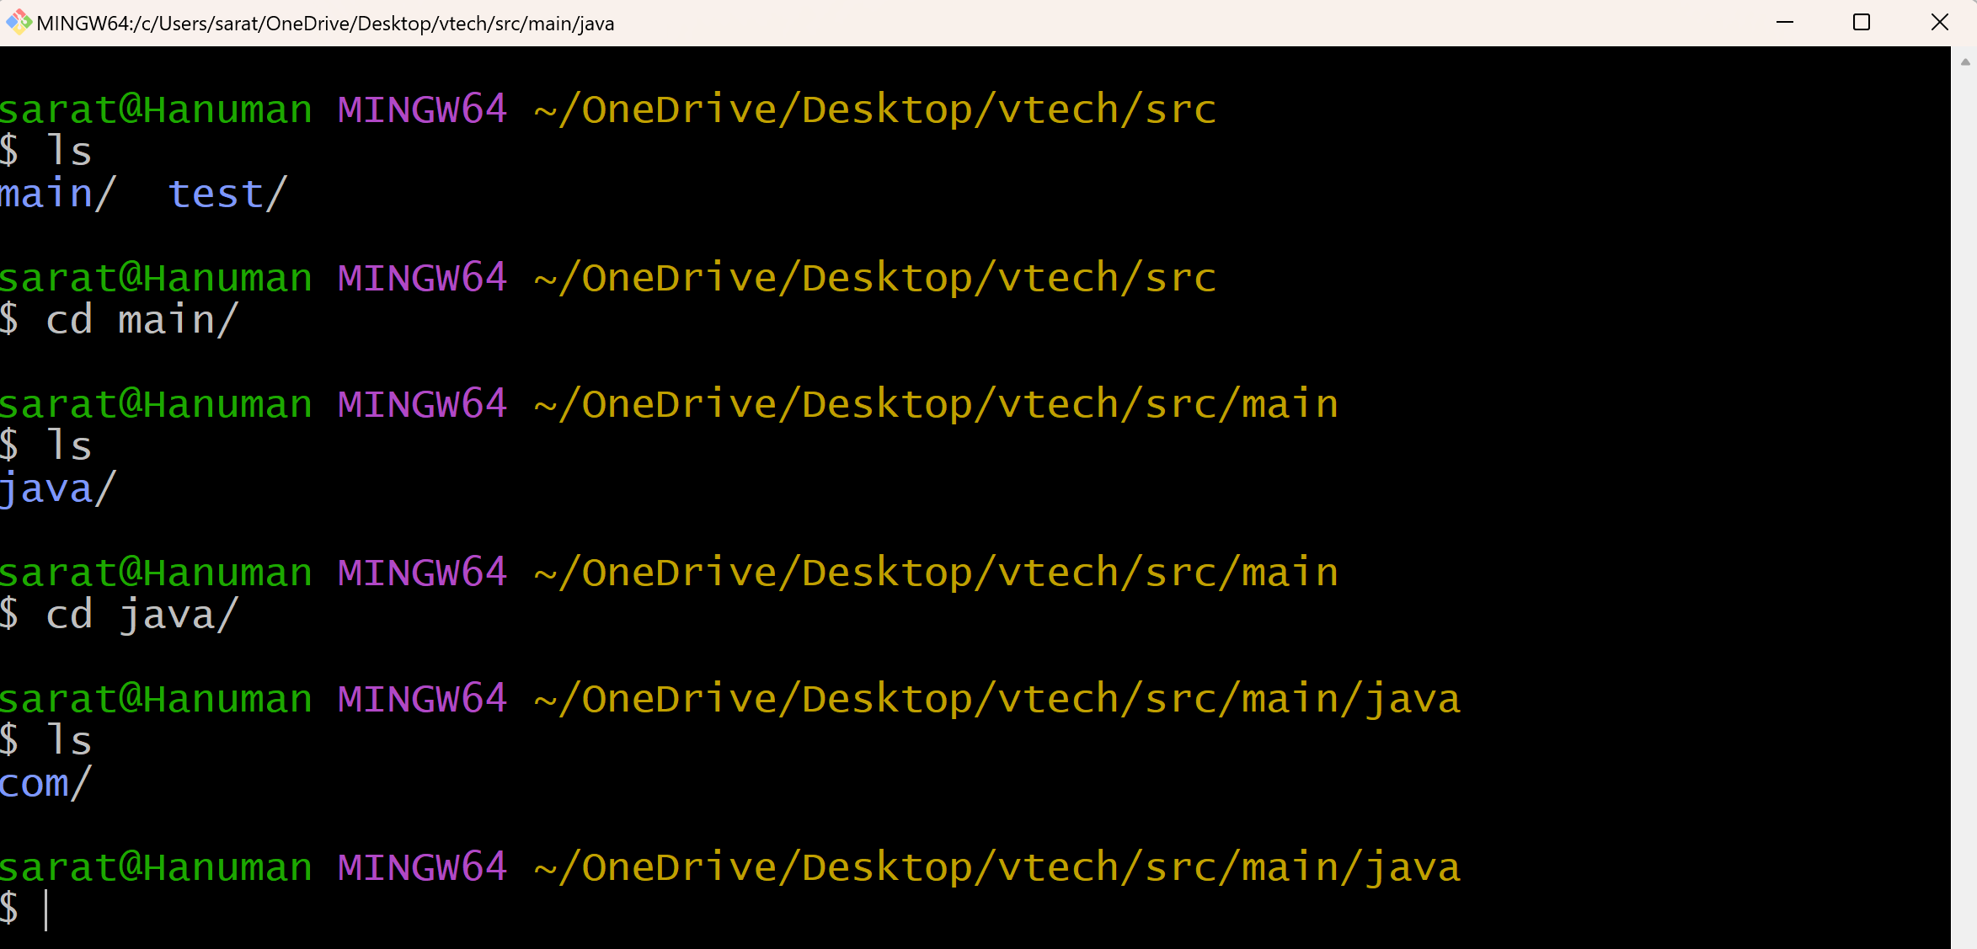

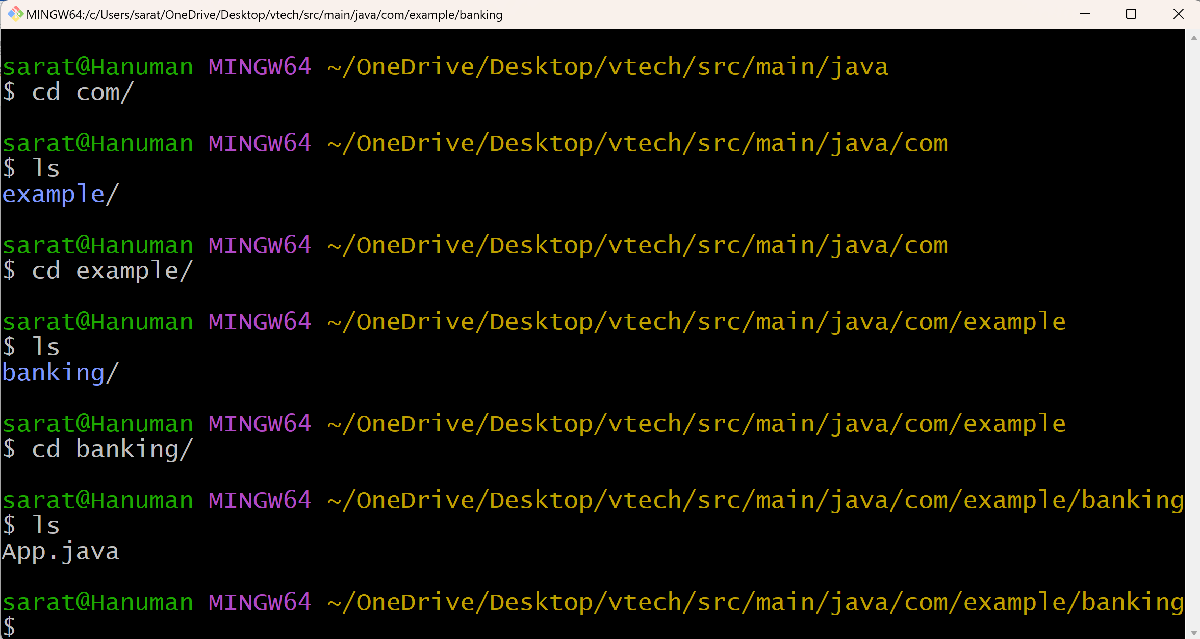

Move back to src folder

cd ../../../../..

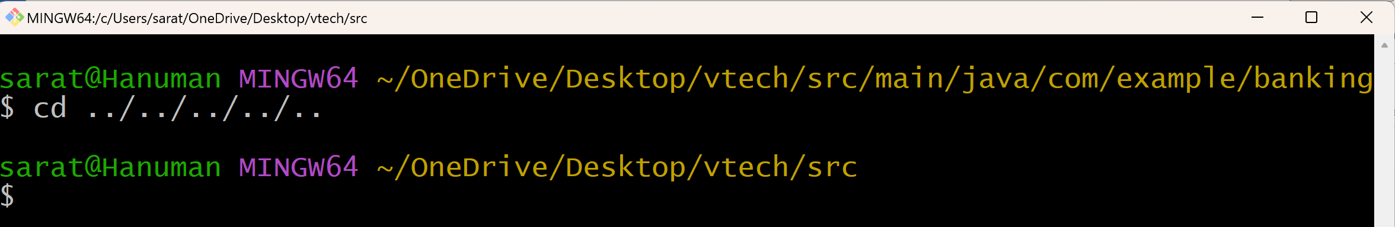

Move to test folder, to check, if AppTest. java file is created

cd test/

cd java/

cd com/

cd example/

cd banking/

ls

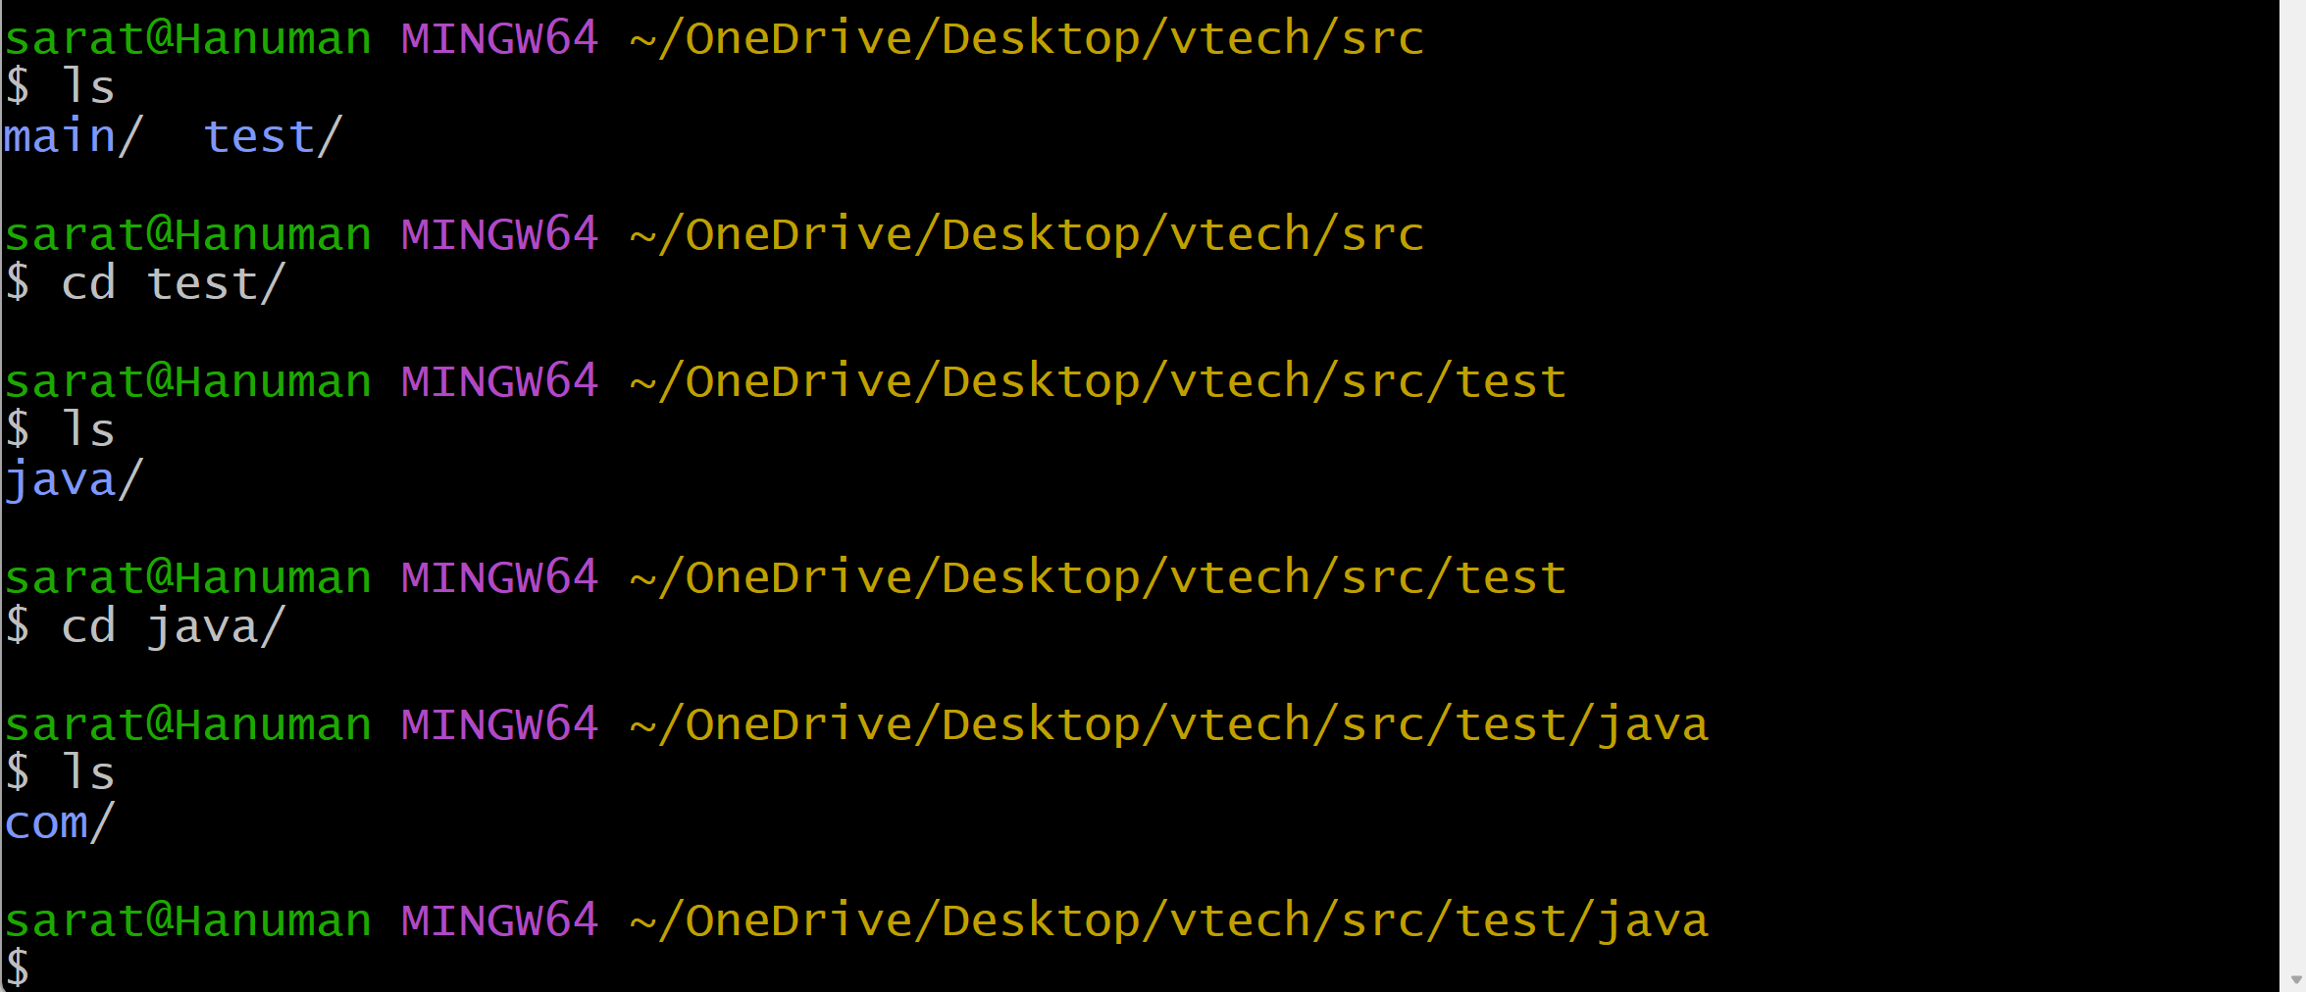

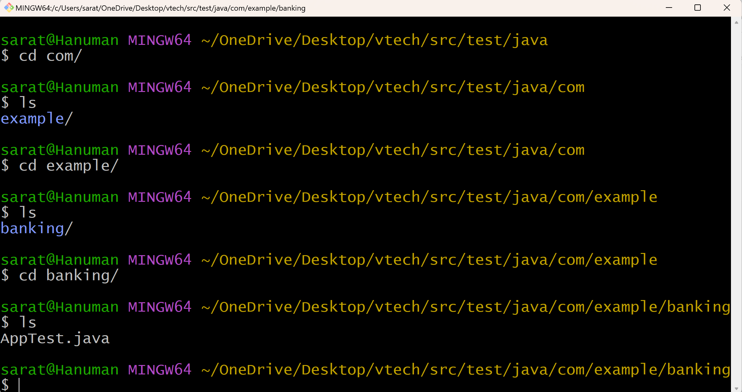

Move to target folder, to check, if artifacts are created

cd ../../../../..

ls

cd ..

ls

cd target/

ls

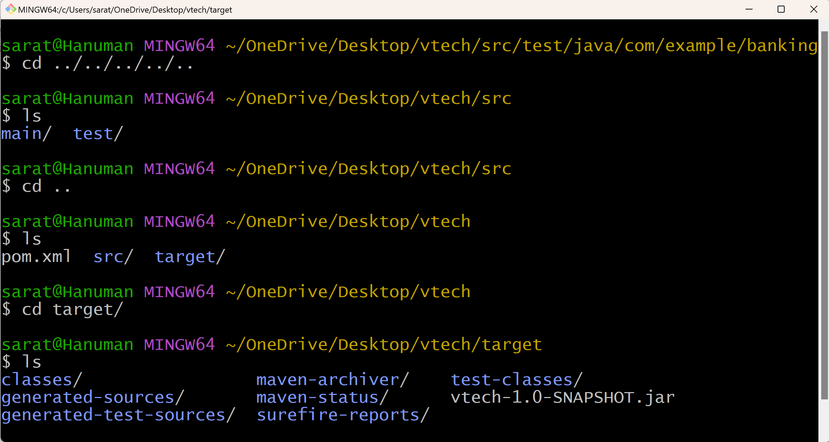

**Remove target folder**

mvn clean

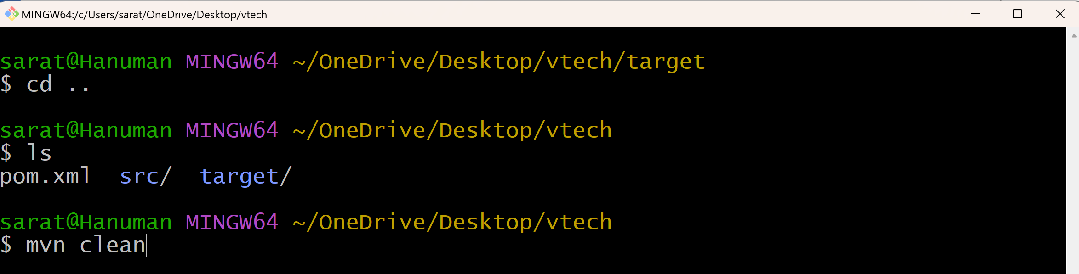

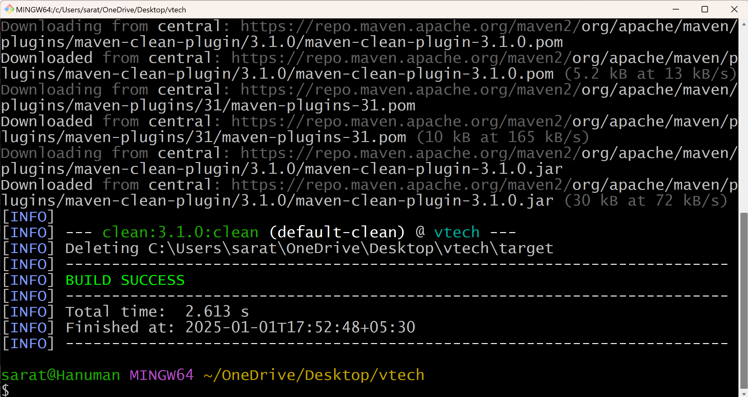

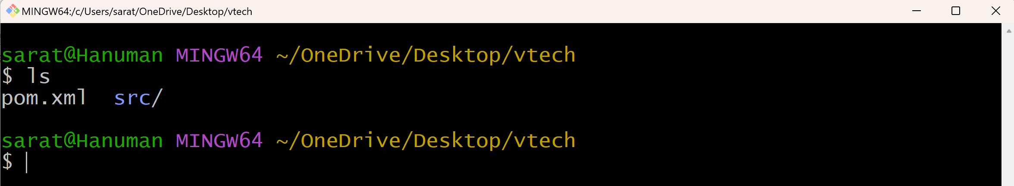

This skeleton is available on our local server.

If this application is needed by other developers, then this skeleton is required for them as well.

For that, we need to move this skeleton to Github.

Then other developers will clone this skeleton into their local servers and so, they will start work on the java code which is available in main folder.

**Push the skeleton to Github**

Go to Github > Go to Your repositories > Click on New > Enter Repository name = vtechbank > Click on ‘Create repository’

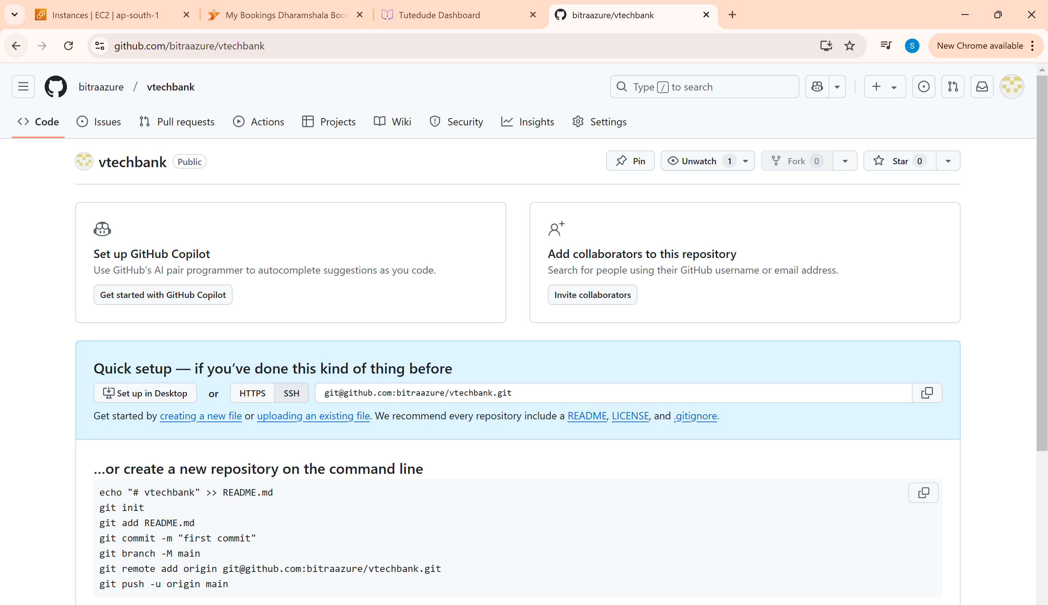

Go to Git bash

git inti

git add .

git commit m “vtech project is added”

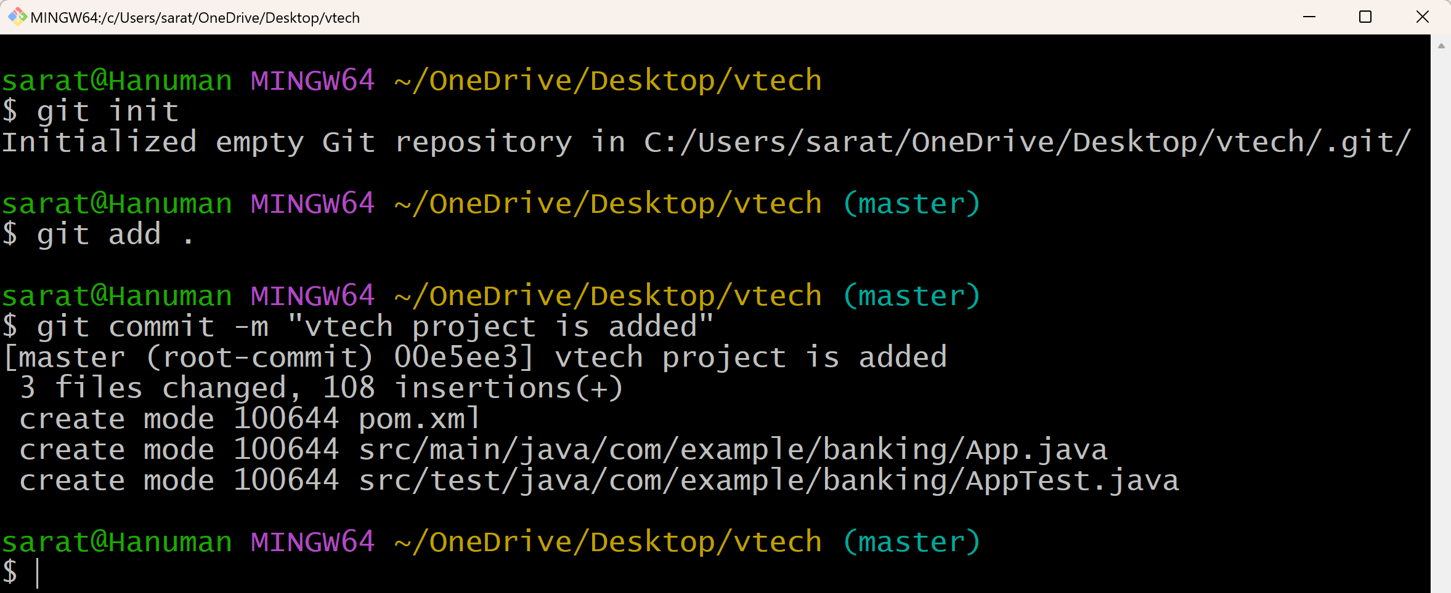

git remote add origin git@github.com:bitraazure/vtechbank.git

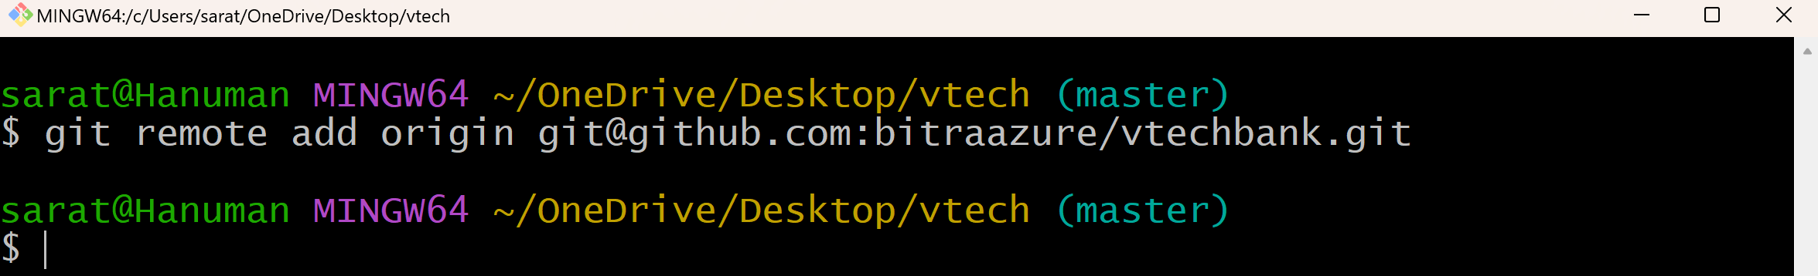

git push -u origin master

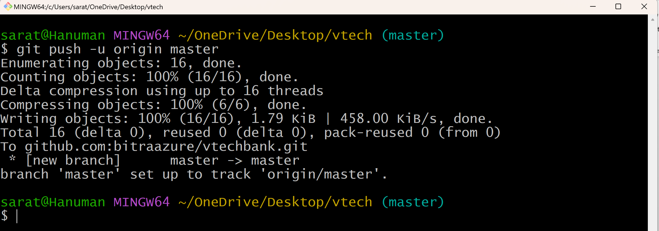

Go to github and refresh

